

**Bilkent University  
 Department of Computer Engineering**

**Senior Design Project  
T2306  
 SecuRent**

**Analysis and Requirement Report**

**Team Members:**

Arda YILDIZ - 22003093 - yarda@ug.bilkent.edu.tr

Mustafa Kaan KOÇ - 21903358 - kaan.koc@ug.bilkent.edu.tr

Yusuf ŞENYÜZ - 21903105 - yusuf.senyuz@ug.bilkent.edu.tr

Cengizhan TERZİOĞLU - 22003014 - cengizhan@ug.bilkent.edu.tr

Yunus Eren TÜRKERİ - 22001842 - eren.turkeri@ug.bilkent.edu.tr

**Supervisor:** Özcan ÖZTÜRK

**Course Instructors:** Atakan ERDEM, Mert BIÇAKÇI

**Date:** 08.12.2023

This report is submitted to the Department of Computer Engineering of Bilkent University in partial fulfillment of the requirements of the Senior Design Project course CS491/2.

**Table of Contents**

**1. Introduction 3**

**2. Current System 3**

2.1 Problem Definition 3

2.2 Possible Competitors 4

**3. Proposed System 5**

3.1 Overview 5

3.2 Functional Requirements 5

3.3 Non-functional Requirements 7

3.3.1 Usability 7

3.3.2 Reliability 7

3.3.3 Supportability 7

3.3.4 Scalability 7

3.3.5 Security 8

3.3.6 Maintainability 8

3.4 Pseudo Requirements 9

3.4.1 Project Management 9

3.4.2 Version Control System 9

3.4.3 Testing 9

3.4.4 External Tools and Technologies 9

3.5 System Models 10

3.5.1 Scenarios 10

3.5.2 Use-Case Model 28

3.5.3 Object and Class Model 33

3.5.4 Dynamic Models 36

3.5.5 User Interface 37

3.5.5.1 Login Page: 38

3.5.5.2 Forgot Your Password: 38

3.5.5.3 Sign Up: 39

3.5.5.4 State Official (Government) Home Page: 39

3.5.5.5 State Official Profile: 40

3.5.5.6 Deposit Side: 40

3.5.5.7 Contracts: 41

3.5.5.8 Approved Contracts: 42

3.5.5.9 Complaint Notifications: 42

3.5.5.10 Handled Complaints: 43

3.5.5.11 Pending Complaints: 44

3.5.5.12 Tenant Home Page: 44

3.5.5.13 Tenant Ad Details: 45

3.5.5.14 Tenant Ad Details (Cont’d): 45

3.5.5.15 Tenant Ad Details (Cont’d): 46

3.5.5.16 Tenant Profile: 46

3.5.5.17 Rate Real Estate Agent for Tenant: 47

3.5.5.18 Rented House: 47

3.5.5.19 Select Agent: 48

3.5.5.20 Landlord Publish Ad: 48

3.5.5.21 Landlord Publish Ad (Cont’d): 49

3.5.5.22 Landlord Publish Ad (Cont’d): 49

3.5.5.23 Landlord Publish Ad (Cont’d): 50

3.5.5.24 Landlord Publish Ad (Cont’d): 50

3.5.5.25 Landlord Publish Ad (Cont’d): 51

3.5.5.26 Landlord Publish Ad (Cont’d): 51

3.5.5.27 Rental Notifications: 52

3.5.5.28 Rate Real Estate Agent for Landlord: 52

3.5.5.29 Current Rental Request: 53

3.5.5.30 Past Rental Request: 53

3.5.5.31 Landlord Profile: 54

3.5.5.32 Real Estate Agent Home Page: 54

3.5.5.33 Real Estate Agent Requests: 55

3.5.5.34 Real Estate Agent Current Requests: 56

3.5.5.35 Real Estate Agent Past Requests: 56

3.5.5.36 Real Estate Agent Profile: 57

3.5.5.37 Real Estate Agent House Condition Check Notification: 58

3.5.5.38 Real Estate Agent House Condition Check Notification: 58

3.5.5.39 Landlord Profile From Another POV: 59

3.5.5.40 Tenant Profile From Another POV: 60

3.5.5.41 Real Estate Agent Profile From Another POV: 60

3.5.5.42 Tenant and Landlord View from Another POV: 61

3.5.5.43 Tenant and Real Estate Agent View from Another POV: 62

3.5.5.44 Create State Official Page: 62

3.5.5.45 List Users Page: 63

3.5.5.46 Update Profile: 64

**4. Other Analysis Elements 64**

4.1 Consideration of Various Factors in Engineering Design 64

4.1.1 Constraints 64

4.1.2 Standards 66

4.2 Risks and Alternatives 67

4.3 Project Plan 68

4.4 Ensuring Proper Teamwork 76

4.5 Ethics and Professional Responsibilities 78

4.6 Planning for New Knowledge and Learning Strategies 78

**5. Glossary 79**

**6. References 79**

**Analysis and Requirement Report: *SecuRent***

# **1.** **Introduction**

The SecuRent is an application which enhances the house rental process as well as addressing the issues that are related with the house rental process. SecuRent application emerges as a pioneering solution designed to transform the dynamics between tenants and landlords. With SecuRent, tenants can request officials (who are assigned by the government) to determine the rental price of a house, if they are not in favor of the price set by the landlord. Thus, ballooned prices set by the landlords can be regulated by the officials to prevent tenants paying more than what is worth for a particular house. Furthermore, if a house is rented, the status of the house will be updated in the application and a contract uploaded by the landlord will enable the government to monitor the contract. If a landlord wants to increase the rent price before the contract expiration date, the government will be notified with a request. Hence, the rent prices will not be increased without the government's consent, ultimately preventing unwanted skyrocketing prices that cause hardships for tenants. Moreover, with SecuRent, the deposit money for houses will be collected at the government treasury. The implication of this use case is that the deposit money will be given to either the tenant or the landlord depending on the condition of the house after the contract expires. Thus, conflicts between tenants and landlords caused by deciding who will keep the deposit money will be solved, as the government will act as the mediator in this process.

# **2.** **Current System**

## **2.1** **Problem Definition**

In the current situation, the renewal time for a rent contract is once per year, according to law [1]. However, this is not the case when it comes to practice. Some landlords still believe that they have the right to increase the rent price before a contract expires in one year. Hence, tenants complain about the unlawful increments in the rent prices, and unfortunately, the complaints lead to heavy discussions between tenants and landlords. Unfortunately, discussions often lead to violence in between two parties. What is more, tenants and landlords often argue about who should keep the deposit of the house, with regards to the conditions of the house after the contract expiration date. Hence, the tension between the two parties tends to increase because of this situation as well.

The SecuRent application resolves/alleviates the aforementioned issues in the following ways: Firstly, SecuRent introduces the government as the guarantor to the renting process. Henceforth, The tenant can request a government official to evaluate the renting price of the house before a contract is signed. Next, within the contract period, if an increment has been made to the rent price by the landlord, the government will interfere, stating that the price increment is illegal. According to the law, no increment can be made to the house rental prices during the contract. Only increment can be made before the contract renewal with 25% increment rate, in regards to the law passed on July 1st 2023 [2]. Hence, as the government will be the authority in the rent process and act as the guarantor for the contract, the unlawful rent price increases will be prevented. Furthermore, with the SecuRent application, the deposit of the rented house will be kept in the government vault. As the contract expires, the conditions of the house will be evaluated by a real estate agent. Therefore, the real estate agent can evaluate the house conditions and register his/her evaluations to the SecuRent system, concluding with a decision on who should keep the deposit. Henceforth, the government can send the deposit to either the tenant or the landlord, upon the real estate agent’s decision. Thus, the disputes between tenants and landlords caused by deciding on who should keep the deposit will be resolved with the contribution of third parties such as the real estate agent and the government, given that they should act objectively.

## **2.2 Possible Competitors**

In the market, there is no robust competitor for this project. There are similar projects that include some features of SecuRent, but these projects do not function similarly and their aims are not the same. On the internet, 2 projects/websites show a similarity in the same application domain as SecuRent: Endeksa and mydeposits.

Endeksa is a service which offers the users to rent, buy, or rent a house. It is supported with machine learning which predicts the market price of a house. The website has some fields to fill in when a landlord creates a publication of a house to be sold. These fields include specific information about the floor, facade and the condition of the flat. Users can also examine in a specific location to look for the renting/selling opportunities [3]. Though it is in the same application domain as SecuRent, the contract system, interactions with the government and the depositing system is different from SecuRent. So, in practice Endeksa is not a challenging competitor for SecuRent since they function differently and they offer different services.

Mydeposits is a service which is constructed by private rental sector experts. It is a deposit protection service which landlords, agents and tenants can use. The website is dedicated and designed to protect the deposits mainly, so there is no governmental profit from these deposits or detailed tracking of contracts [4]. Regarding these missing features, mydeposits is not a powerful competitor for SecuRent since the functionalities and scope is different.

# 

# **3.** **Proposed System**

## **3.1 Overview**

SecuRent is a web application which easens the house rental process as well as addressing the unlawful rent price increment and deposit retrieval problems. SecuRent is innovative since there is no application that resolves the unlawful rent price increment and deposit retrieval conflicts.

The system will follow a three layered architectural style: Presentation layer, business layer, and data layer. In the presentation layer, we are enabling the clients to interact with the system. Hence, we are implementing the front end of the system. To do this, we are using JSX syntax of JavaScript alongside React.js library of JavaScript, as well as Bootstrap. Proceeding from the presentation layer to the business layer, we are using Axios to handle the communication between these layers. In the business layer, we are implementing the business logic of the SecuRent system. Hence, we are implementing the back end functionality of the system, while responding to the functional and non functional constraints that will be discussed next. We are using the Java programming language and Spring Boot framework to implement the business layer. Lastly, we have the data layer, which stores the entities and their properties. To implement this layer, we will use PostgreSQL, a relational database, which will be in communication with the business layer through SQL queries. Last but not least, since SecuRent is intended to be an enterprise application, we are planning to use Amazon Web Services (AWS) to host our application. Specifically, we will use Amazon Elastic Compute Cloud (Amazon EC2) to achieve a scalable and adjustable application, as EC2 comes with the features responding to the increasing numbers of users or sudden spikes (stark increments in the number of users) [5].

## **3.2** **Functional Requirements**

In this section, the functional requirements of the system are addressed. The functional requirements are determined such that they are corresponding to the features of the system.

* Users must sign up to the system by entering their credentials.
* Users must login to the system by using their email and password.
* Users can log out of the system
* Users can delete their account.
* Users can search the rental houses according to their region and address.
* Tenants can pay the deposit amount through the application.
* Tenants can send a renting request to landlords.
* Tenants can cancel an already sent renting request to a landlord.
* Tenants can request rental service from a real estate agent.
* Tenants can request evaluation of house conditions by a real estate agent when the contract expires.
* Tenants can request a rent price to be recalculated if they think the rent price is extremely high. A remark, this request will be made to the government and this request can only be made after 3 months from the last rent price recalculation request.
* Tenants can accept extension notifications sent by the system in the last week of their contract.
* Tenants can report a rental ad given that there is a problem with the rental ad (for instance, the number of rooms is less than what has been stated in the rental ad).
* Landlords can register their houses to the system. Landlords can enter the additional information of their houses such as property type, area of the house, room number, the floor where it is located, heating of the house.
* Landlords can upload images of their houses.
* Landlords can create a rental ad for their registered houses.
* Landlords can delete their house.
* Landlords can delete their rental ads.
* Landlords can update their houses.
* Landlords can update their rental ads.
* Landlords can either accept or reject the rent requests sent by the tenants.
* Landlords can upload the rent contract to the system.
* Real estate agents can evaluate house conditions when they are requested for evaluation by tenants.
* Real estate agents can create profiles and provide services to tenants.
* Real estate agents can upload the form about the deposit, if the deposit should be returned to the tenant or given to the landlord due their evaluation of the house conditions. The evaluation report will be examined by the government and will be used for who will have the deposit.
* Real estate agents can view the rental houses in their location.
* Real estate agents can assist the rental process when they are contacted.
* Government can assign officials to identify the price of the house.
* Government can monitor, confirm or decline the contracts.
* Government can return the deposit to the tenants, due to the real estate agent’s evaluation.
* Government can give the deposit to the landlord if the house is damaged, due to the real estate agent’s evaluation.
* Government can restrict the rent increase rate yearly (currently 25% according to law).
* Government can detect the rent increases that do not comply with the regulation. The rent increase will be calculated by an automated function in the system and will be reported to the government, in the case of an illegitimate increase.
* Government can send a request to correct the information on the rental ad, if the landlord’s rental ad and the house have mismatching information.
* The admin can create profiles for state officials (government).
* The admin can update a user profile.
* The system can send extension upon the termination of the rental contract

## 3.3 Non-functional Requirements

In this section, the non-functional requirements (NFR) of the system are addressed. The non-functional requirements are the quality attributes of SecuRent system.

### 3.3.1 Usability

To enhance the usability, the user interface must be simple and easy to understand. Users of the application can vary substantially. Users from all age groups (starting from 18 years old minimum) should be able to use the application without difficulty. Our aim is to make an application that the most of the citizens of Turkey will use. Possible tenants should be able to access the particular home within at most 10 clicks. To ensure the usability, we are designing simple and easy to understand home pages, navigation bars and user interfaces in general.

### 3.3.2 Reliability

As mentioned in the previous part, this application has the possibility of being used by tens of millions of people. For this reason, the application must be reliable and it should not crash in millions of user traffic. Moreover, to ensure the reliability of our application, we will write unit tests for our front end and back end source codes. Hence, we will test the code that we have written. The standard that we have come to consensus is that we will have a coverage rate of 80% to ensure reliability via unit tests. Moreover, we will benefit from the AWS EC2 to host our application, which will ensure that the application will not crash with the increasing number of users. Last but not least, we will implement rate limits to our front end and back end source codes, to prevent our application crashing from DDoS attacks. Hence, our application will not be met with an enormous number of requests (such as 10000 requests) within a millisecond, and will not crash.

### 3.3.3 **Supportability**

SecuRent is aimed to be used for at least 10 years. In its lifetime, new technologies may arise and some of the users might start to use these technologies. SecuRent should be accessible in these new technologies because it will have millions of users all around Turkey. For instance, SecuRent should work smoothly in different browsers such as Chrome, Opera, Edge etc. Thus, the application should also support a new/emerging browser as well to ensure supportability.

### 3.3**.4 Scalability**

SecuRent is aimed to be used by all the tenants, landlords and real estate agents in the country. Therefore, it will already be used by possibly thousands or millions of users beginning from the first day it becomes live. Also the number of the potential users might increase as the population of the country increases or more houses are built in the long term. Hence, SecuRent should be scalable to be able to increase the capacity of the servers when it is needed. Therefore, we are integrating Amazon EC2 in our system to host and respond to the increasing number of users. With EC2’s tailored scalability options, we will address the issue of increasing number of users.

### 3.3**.5 Security**

SecuRent collects countless sensitive data such as Turkish Republic identity number, address and phone number of the users, contract information, etc. All of this data must be protected by encryption. Moreover, the multi factor authentication must be added to the system, with a confirmation mail sent to a user. Furthermore, the tenants will make payments through the application. Money transactions must be secure so that no user loses their money. Hence, we will cooperate with multi factor authentication again to provide security. Last but not least, we will implement rate limits to our front end and back end source codes, to prevent our application crashing from DDoS attacks. Hence, our application will not be met with an enormous number of requests (such as 10000 requests) within a millisecond, and will not crash, as mentioned in the reliability section as well.

### 3.3.6 Maintainability

To ensure maintainability we have made a set of architectural and design decisions. Here is a list of the decisions we have made to provide maintainability in our application:

* We will provide documentation for our codebase through README.md files and our webpage. Hence, the documentation will act as a guide when maintenance is required.
* We have decided to use module style as our architectural style. Hence, we will implement our system in modules, which comes with meaningful units of development in itself. Thus, when maintaining the codebase, each module can be put into investigation separately.
* We are using version control tools such as Git. We are committing with meaningful and self descriptive commit messages. Hence, it becomes easier to backtrack and build upon a certain commit when needed.
* We will use SonarQube to have clean code in our codebase. Therefore, we will follow the common coding practices and correct our critical issues via SonarQube tool to have a more maintainable code.
* We are providing comments in our codebase to help each other work efficiently. Therefore, multiple people can work and communicate effectively on the same source code with the help of the comments. Moreover, when someone takes over the codebase in the future, the comments will help the future developers to understand the legacy code easier and ultimately maintain it easier as well.

## 3.4 Pseudo Requirements

### 3.4.1 Project Management

* Agile project management methodology is followed. Specifically, the SCRUM framework is followed. The main principle is to produce quality software in small units and continuously as opposed to waterfall working methodology.
* To follow the SCRUM easier and more effectively, Jira project management tool must be used.
* Each duration of a sprint is decided as 2 weeks. Biweekly stand up meetings are scheduled to allow active communication between front end, and back end teams.
* Backlog refinement and iteration retrospective are scheduled to see and learn from our mistakes. Hence, we can learn what we need to refine before a sprint and understand important results from our mistakes.

### 3.4.2 Version Control System

* Git is used as a version control system. Moreover, GitHub serves as the designated version control system repository to track changes.
* Commit messages should follow the principle of self descriptiveness.
* No developer should push changes to the main branch. Developments should be done in the feature branches.
* Main branch will be protected by code reviews before merging with a feature branch.

### 3.4.3 Testing

* Unit tests are written for each source code either for the front end or for the back end.
* For front end unit tests, we will use Karma for configuration and Jasmine for testing. Jasmine is selected for testing due to its easy to understand syntax and the familiarity of the members. Since we are using React.js for the front end, the above tools are compatible.
* For back end unit tests, we will use JUnit to write and test our test cases. Since JUnit comes with the Spring Boot by default, and as some of the members have familiarity, we decided to use JUnit.
* We will have a code coverage of 80% coverage rate. We decided the rate by inquiring senior developers who have experience in unit testing.

### 3.4.4 External Tools and Technologies

* As our main communication platform, we are using Discord, due to its high performance and ease of use.
* For online meetings, we are using Google Meet.
* For documentation, we are using Google Docs, thanks to its ease of use and collaborative feature.
* We are using draw.io to draw our high level architecture, use case and class diagrams.
* SonarQube will be used for having clean code standards.
* Amazon EC2 will be used for hosting purposes.

## **3.5** **System Models**

### **3.5.1** Scenarios

| **Scenario 1** |  |
| --- | --- |
| **Use Case Name** | Sign Up |
| **Participating Actors** | User |
| **Entry Conditions** | * Application must be open. * The user must not be logged in. |
| **Exit Conditions** | 1. The user has a new account if they click the “Sign Up” button. 2. Sign up is canceled if the user clicks the “Back” button. |
| **Main Flow of Events** | 1. Open the application. 2. Click on the “Sign Up” button. 3. Fill required input fields. 4. Click on “Sign Up” to create a new user in the application or “Back” to cancel the registration. |

### 

| **Scenario 2** |  |
| --- | --- |
| **Use Case Name** | Login |
| **Participating Actors** | User |
| **Entry Conditions** | * Application must be open. * The user must not be logged in. |
| **Exit Conditions** | 1. User is logged in if they have entered valid credentials and clicked on the “Login” button. 2. An error message pops up if the user has entered invalid credentials and clicked on the “Login” button. User stays in the login page. |
| **Main Flow of Events** | 1. Open the application. 2. Enter credentials. 3. Click on the “Login” button. |

### 

| **Scenario 3** |  |
| --- | --- |
| **Use Case Name** | Logout |
| **Participating Actors** | User |
| **Entry Conditions** | * Application must be open. * The user must be logged in. |
| **Exit Conditions** | 1. User is logged out of the application. They are returned to the login page. |
| **Main Flow of Events** | 1. Open any page of the application. 2. Click on the “Logout” button. |

### 

| **Scenario 4** |  |
| --- | --- |
| **Use Case Name** | Search House |
| **Participating Actors** | Tenant, Landlord, Real Estate Agent |
| **Entry Conditions** | * Application must be open. * The user must be logged in. * The user must be in the search houses page. |
| **Exit Conditions** | 1. User retrieves a list of houses that contain the search condition as a substring. |
| **Main Flow of Events** | 1. Enter a text input as a string. 2. Click on the “Search” button. |

### 

| **Scenario 5** |  |
| --- | --- |
| **Use Case Name** | Filter House |
| **Participating Actors** | Tenant, Landlord, Real Estate Agent |
| **Entry Conditions** | * Application must be open. * The user must be logged in. * The user must be in the search houses page. |
| **Exit Conditions** | 1. Houses that do not fit to the filtering conditions are removed from the house list. |
| **Main Flow of Events** | 1. Click on the “Filters” button. 2. Select the desired filtering options. 3. Click on the “Filter” button. |

### 

| **Scenario 6** |  |
| --- | --- |
| **Use Case Name** | Rent House |
| **Participating Actors** | Tenant |
| **Entry Conditions** | * Application must be open. * The tenant must be logged in. * The tenant must have selected a rental ad to observe. |
| **Exit Conditions** | 1. House is rented if the tenant clicked on the “Rent” button for a house and the corresponding landlord accepted the renting request. 2. House is not rented if the tenant clicked on the “Rent” button for a house and the corresponding landlord rejected the renting request. 3. House is not rented if the tenant clicks on the “Cancel” button. |
| **Main Flow of Events** | 1. Select a house. 2. Click on the “Rent” button. 3. Send a renting request to the landlord. 4. Either click on the “Cancel” button or wait for the landlord's response. |

### 

| **Scenario 7** |  |
| --- | --- |
| **Use Case Name** | Send Renting Request to Landlord |
| **Participating Actors** | Tenant |
| **Entry Conditions** | * Application must be open. * The tenant must be logged in. * The tenant must have selected a rental ad to observe. |
| **Exit Conditions** | 1. A notification is sent to the corresponding landlord. |
| **Main Flow of Events** | 1. Click on the “Confirm” button for “Are you sure to rent this house?” pop up question. |

### 

| **Scenario 8** |  |
| --- | --- |
| **Use Case Name** | House Already Rented |
| **Participating Actors** | Tenant |
| **Entry Conditions** | * Application must be open. * The tenant must be logged in. * The tenant must have selected a rental ad to observe. |
| **Exit Conditions** | 1. An error message pops up to indicate the selected house is already rented. |
| **Main Flow of Events** | 1. Click on the “Confirm” button for the “Are you sure to rent this house?” pop up question. 2. Error pops up. |

### 

| **Scenario 9** |  |
| --- | --- |
| **Use Case Name** | Request Rental Service |
| **Participating Actors** | Tenant |
| **Entry Conditions** | * Application must be open. * The tenant must be logged in. * The tenant must be on the rent house page. |
| **Exit Conditions** | 1. A notification is sent to the selected real estate agent for rental service request |
| **Main Flow of Events** | 1. Click on the “Request Rental Service” button. 2. Choose the desired area for the house. 3. Choose a real estate agent working in the selected area. 4. Click the “Send Request” button. |

### 

| **Scenario 9** |  |
| --- | --- |
| **Use Case Name** | Request House Conditions Evaluation |
| **Participating Actors** | Tenant |
| **Entry Conditions** | * Application must be open. * The tenant must be logged in. * Rental contract must have an expiration date less than 1 week. |
| **Exit Conditions** | 1. A notification is sent to the selected real estate agent for house conditions evaluation service request |
| **Main Flow of Events** | 1. Click on the “House Conditions Evaluation” button. 2. Choose a real estate agent working in the area of the rented house. 3. Click the “Send Request” button. |

### 

| **Scenario 10** |  |
| --- | --- |
| **Use Case Name** | No Available Real Estate Agent |
| **Participating Actors** | Tenant |
| **Entry Conditions** | * Application must be open. * The tenant must be logged in. * Tenant must have clicked on “Request Rental Service” and selected the desired are for this request or “House Conditions Evaluation” button |
| **Exit Conditions** | 1. An error message pops up indicating there are no available real estate agents working in the area. |
| **Main Flow of Events** | 1. Click on one of the request buttons. 2. Error message pops up. |

### 

| **Scenario 11** |  |
| --- | --- |
| **Use Case Name** | Request House Price Evaluation |
| **Participating Actors** | Tenant |
| **Entry Conditions** | * Application must be open. * The tenant must be logged in. * The tenant must have selected a house to rent. * Latest price evaluation for this house must have been 3 months ago if the price didn’t change after it. |
| **Exit Conditions** | 1. A notification is sent to the government so that an expert can be assigned to evaluate the rent price. |
| **Main Flow of Events** | 1. Click on the “Request House Price Evaluation” button. |

### 

| **Scenario 12** |  |
| --- | --- |
| **Use Case Name** | Pay Deposit |
| **Participating Actors** | Tenant |
| **Entry Conditions** | * Application must be open. * The tenant must be logged in. * Tenant must have rented a house. * The tenant must not have paid a deposit for a house. |
| **Exit Conditions** | 1. Tenant has paid their deposit. Deposit is sent to the government. |
| **Main Flow of Events** | 1. Click on the “Pay Deposit” button. 2. Enter payment information. 3. Click on the “Confirm Payment” button. |

### 

| **Scenario 13** |  |
| --- | --- |
| **Use Case Name** | Report an Ad |
| **Participating Actors** | Tenant |
| **Entry Conditions** | * Application must be open. * The tenant must be logged in. * The tenant must have selected a rental ad to observe. |
| **Exit Conditions** | 1. A notification is sent to the government so that they can investigate what’s wrong with the ad. |
| **Main Flow of Events** | 1. Click on the “Report” button. 2. Fill in the comment box. 3. Click on the “Send” button. |

### 

| **Scenario 14** |  |
| --- | --- |
| **Use Case Name** | Register a House |
| **Participating Actors** | Landlord |
| **Entry Conditions** | * Application must be open. * Landlord must be logged in. |
| **Exit Conditions** | 1. The landlord has added their house to the system. |
| **Main Flow of Events** | 1. Click on the “Register House” button. 2. Fill in the properties of the house. 3. Click on the “Register” button. |

### 

| **Scenario 15** |  |
| --- | --- |
| **Use Case Name** | Give Rental Ad |
| **Participating Actors** | Landlord |
| **Entry Conditions** | * Application must be open. * Landlord must be logged in. * The landlord must have at least one house in the system. |
| **Exit Conditions** | 1. A rental ad for the selected house is created. Tenants can use this ad to rent the house. |
| **Main Flow of Events** | 1. Click on the “My Houses” button. 2. Select one of the houses. 3. Enter ad related information. 4. Click on the “Publish Ad” button. |

### 

| **Scenario 16** |  |
| --- | --- |
| **Use Case Name** | Update Rental Ad |
| **Participating Actors** | Landlord |
| **Entry Conditions** | * Application must be open. * Landlord must be logged in. * The landlord must have at least one rental ad in the system. |
| **Exit Conditions** | 1. Details of the rental ad are updated. |
| **Main Flow of Events** | 1. Click on the “My Ads” button. 2. Select one of the ads. 3. Click on the “Update” button. 4. Change the desired details of the ad. 5. Click on the “Confirm Changes” button. |

### 

| **Scenario 17** |  |
| --- | --- |
| **Use Case Name** | Delete Rental Ad |
| **Participating Actors** | Landlord |
| **Entry Conditions** | * Application must be open. * Landlord must be logged in. * The landlord must have at least one rental ad in the system. |
| **Exit Conditions** | 1. Selected rental ad is deleted from the system. |
| **Main Flow of Events** | 1. Click on the “My Ads” button. 2. Select one of the ads. 3. Click on the “Delete” button. |

### 

| **Scenario 18** |  |
| --- | --- |
| **Use Case Name** | House in Rental Process |
| **Participating Actors** | Landlord |
| **Entry Conditions** | * Application must be open. * Landlord must be logged in. * Landlord must have tried to delete a rental ad while it has a rental request from at least one tenant.. |
| **Exit Conditions** | 1. All the rental requests are rejected. Then the rental ad is deleted from the system. 2. Landlord canceled the deletion of the ad. |
| **Main Flow of Events** | 1. Click on the “Delete” button. 2. A message pops up to make sure the landlord will be rejecting all rental requests coming from the tenants in the process. 3. Click on the “Yes” button to reject all requests and delete the ad or the “No” button to cancel the process. |

| **Scenario 19** |  |
| --- | --- |
| **Use Case Name** | Delete Owned House |
| **Participating Actors** | Landlord |
| **Entry Conditions** | * Application must be open. * Landlord must be logged in. * The landlord must have at least one house in the system. |
| **Exit Conditions** | 1. House is removed from the system. |
| **Main Flow of Events** | 1. Click on the “My Houses” button. 2. Select one of the houses. 3. Click on the “Delete” button. |

### 

| **Scenario 20** |  |
| --- | --- |
| **Use Case Name** | House Already Rented |
| **Participating Actors** | Landlord |
| **Entry Conditions** | * Application must be open. * Landlord must be logged in. * Landlord must have tried to delete a house which is currently rented. |
| **Exit Conditions** | 1. An error message pops up indicating the house is already rented therefore it cannot be deleted from the system. |
| **Main Flow of Events** | 1. Click on the “Delete” button. 2. Error message pops up. |

### 

| **Scenario 21** |  |
| --- | --- |
| **Use Case Name** | House is in Rental Ad |
| **Participating Actors** | Landlord |
| **Entry Conditions** | * Application must be open. * Landlord must be logged in. * Landlord must have tried to delete a house while it is in a rental ad. |
| **Exit Conditions** | 1. The rental ad for the selected house is deleted. Then the house is deleted from the system. 2. Landlord canceled the deletion of the house.. |
| **Main Flow of Events** | 1. Click on the “Delete” button. 2. A message pops up to make sure the landlord will be deleting the rental ad in the process. 3. Click on the “Yes” button to delete both the ad and the house or the “No” button to cancel the process. |

| **Scenario 22** |  |
| --- | --- |
| **Use Case Name** | Update House |
| **Participating Actors** | Landlord |
| **Entry Conditions** | * Application must be open. * Landlord must be logged in. * Landlord must have at least one house in the system. |
| **Exit Conditions** | 1. Properties of the house are updated. |
| **Main Flow of Events** | 1. Click on the “My Houses” button. 2. Select one of the houses. 3. Click on the “Update” button. 4. Change the desired properties of the house. 5. Click on the “Confirm Update” button. |

| **Scenario 23** |  |
| --- | --- |
| **Use Case Name** | Confirm Rental Request from a Tenant |
| **Participating Actors** | Landlord |
| **Entry Conditions** | * Application must be open. * Landlord must be logged in. * One of the rental ads of the landlord must have received at least one rental request. |
| **Exit Conditions** | 1. If clicked on “Confirm”, the selected request is confirmed and all the other requests are rejected. 2. If clicked on “Reject”, the selected request is rejected. |
| **Main Flow of Events** | 1. Click on the “My Ads” button. 2. Select one of the ads. 3. Select one of the rental requests on this ad. 4. Click on either the “Confirm” or the “Reject” button. 5. If clicked on the “Confirm” button, proceed to upload the rental contract. |

| **Scenario 24** |  |
| --- | --- |
| **Use Case Name** | Confirm Rental Request from a Tenant |
| **Participating Actors** | Landlord |
| **Entry Conditions** | * Application must be open. * Landlord must be logged in. * Landlord must have confirmed a rental request. |
| **Exit Conditions** | 1. Rental contract between the tenant and the landlord is uploaded to the system. It is sent to the government for supervision. |
| **Main Flow of Events** | 1. Click on the “Choose File” button. 2. Select the contract from the computer as a pdf file. 3. Click on the “Upload” button. |

| **Scenario 25** |  |
| --- | --- |
| **Use Case Name** | Decide Rental Period Extension |
| **Participating Actors** | Tenant, Landlord |
| **Entry Conditions** | * Application must be open. * Either tenant or landlord must be logged in. * Rental period must be ending in a week. |
| **Exit Conditions** | 1. Rental period is extended if both the tenant and the landlord accept. 2. Rental period ends if the tenant or the landlord rejects. |
| **Main Flow of Events** | 1. Click on the “Accept” button to extend the period or the “Reject” button to end the period. 2. Wait for the other party’s response. |

| **Scenario 26** |  |
| --- | --- |
| **Use Case Name** | Rate Real Estate Agent |
| **Participating Actors** | Tenant, Landlord |
| **Entry Conditions** | * Application must be open. * Either tenant or landlord must be logged in. * Tenant or landlord received service from a real estate agent. |
| **Exit Conditions** | 1. Real estate agent is rated. |
| **Main Flow of Events** | 1. Select one of the services provided before. 2. Rate the real estate agent. 3. Click on the “Send” button. |

| **Scenario 27** |  |
| --- | --- |
| **Use Case Name** | Assign Expert to House |
| **Participating Actors** | Government |
| **Entry Conditions** | * Application must be open. * Government must be logged in. * A tenant has requested a rental price evaluation service. |
| **Exit Conditions** | 1. Expert with the least workload is assigned to the house. |
| **Main Flow of Events** | 1. Select a house price evaluation service. 2. Click on the “Assign” button. |

| **Scenario 28** |  |
| --- | --- |
| **Use Case Name** | Monitor Contracts |
| **Participating Actors** | Government |
| **Entry Conditions** | * Application must be open. * Government must be logged in. |
| **Exit Conditions** | 1. All contracts are listed. |
| **Main Flow of Events** | 1. Click on the “Contracts” button. |

| **Scenario 29** |  |
| --- | --- |
| **Use Case Name** | Confirm Contract |
| **Participating Actors** | Government |
| **Entry Conditions** | * Application must be open. * Government must be logged in. * Government must be monitoring the contracts. * Contract must not be approved or rejected. |
| **Exit Conditions** | 1. Selected contract is approved if there are no issues. 2. Otherwise the contract is rejected. |
| **Main Flow of Events** | 1. Select a contract. 2. Click on the “Confirm” button to approve it and the “Reject” button to reject it. |

| **Scenario 30** |  |
| --- | --- |
| **Use Case Name** | Redistribute Deposits |
| **Participating Actors** | Government |
| **Entry Conditions** | * Application must be open. * Government must be logged in. * Real estate agent decided who will receive the deposit back. |
| **Exit Conditions** | 1. Government returns deposit to the specified user. |
| **Main Flow of Events** | 1. Select an ended contract. 2. Select the user who deserves the deposit according to the real estate agent’s evaluation on house conditions when the contract expires. 3. Click on the “Send” button. |

| **Scenario 31** |  |
| --- | --- |
| **Use Case Name** | Resolve Conflict |
| **Participating Actors** | Government |
| **Entry Conditions** | * Application must be open. * Government must be logged in. * A tenant must have sent a report for an ad. |
| **Exit Conditions** | 1. Government sends a notification to the landlord to correct the mismatching information on the rental ad and the house. |
| **Main Flow of Events** | 1. Request assistance from a real estate agent to investigate the house. 2. Assigned real estate agent investigates the house and verifies if there is misled information in the rental ad. 3. Send a request to the landlord that he/she must correct the rental ad to reflect the true conditions of the house. |

| **Scenario 32** |  |
| --- | --- |
| **Use Case Name** | Determine Price |
| **Participating Actors** | Expert |
| **Entry Conditions** | * Application must be open. * Expert must be logged in. * A tenant must have requested a house price evaluation service. |
| **Exit Conditions** | 1. Price of the house is determined. |
| **Main Flow of Events** | 1. Select one of the assigned houses. 2. Enter price. 3. Click on the “Update” button. |

| **Scenario 33** |  |
| --- | --- |
| **Use Case Name** | Evaluate House Conditions |
| **Participating Actors** | Real Estate Agent |
| **Entry Conditions** | * Application must be open. * Real estate agents must be logged in. * A tenant must have requested a house conditions evaluation service. |
| **Exit Conditions** | 1. Retriever of the deposit is selected. |
| **Main Flow of Events** | 1. Select one of the houses where house condition service is requested. 2. Choose the tenant if the house conditions are good, otherwise choose the landlord. |

| **Scenario 34** |  |
| --- | --- |
| **Use Case Name** | Assist Rental Process |
| **Participating Actors** | Real Estate Agent |
| **Entry Conditions** | * Application must be open. * Real estate agent must be logged in. * A tenant must have requested an assist rental process service. |
| **Exit Conditions** | 1. Real estate agent assisted the tenant. |
| **Main Flow of Events** | 1. Go to the houses requested by the tenant one by one. 2. Tour around with the tenant. 3. Explain house properties. 4. Click on the “Finalize” button to end the service. |

| **Scenario 35** |  |
| --- | --- |
| **Use Case Name** | Assist Conflict Resolution |
| **Participating Actors** | Real Estate Agent |
| **Entry Conditions** | * Application must be open. * Real estate agent must be logged in. * Government must have requested conflict resolution. |
| **Exit Conditions** | 1. Real estate agent decides whether the report is valid or invalid |
| **Main Flow of Events** | 1. Evaluate the house. 2. Compare the report with the house properties. 3. If they mismatch, click on the “Valid” button. Otherwise, click on the “Invalid” button. |

| **Scenario 36** |  |
| --- | --- |
| **Use Case Name** | Open Government Account |
| **Participating Actors** | Admin |
| **Entry Conditions** | * Application must be open. * An admin must be logged in. |
| **Exit Conditions** | 1. A government account is created. |
| **Main Flow of Events** | 1. Click on the “Create a New Government Account” button. 2. Fill the necessary information. 3. Click on the “Create” button. |

| **Scenario 37** |  |
| --- | --- |
| **Use Case Name** | List Users |
| **Participating Actors** | Admin |
| **Entry Conditions** | * Application must be open. * An admin must be logged in. |
| **Exit Conditions** | 1. All users are listed. |
| **Main Flow of Events** | 1. Click on “List Users” button. |

| **Scenario 38** |  |
| --- | --- |
| **Use Case Name** | Update User |
| **Participating Actors** | Admin |
| **Entry Conditions** | * Application must be open. * An admin must be logged in. * Admin must have listed the users. |
| **Exit Conditions** | 1. A user’s account info is updated. |
| **Main Flow of Events** | 1. Select one of the users. 2. Change the desired information about the selected user. 3. Click on the “Update” button. |

### 

### **3.5.2** **Use-Case Model**

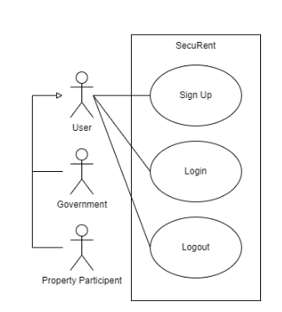

Figure 1: Use case diagram for sessions

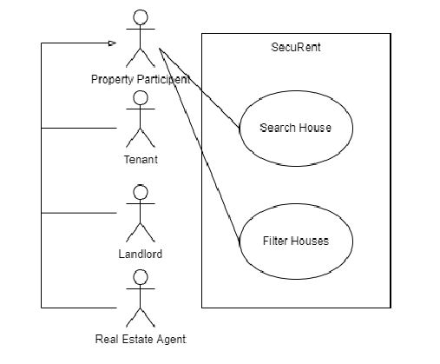

Figure 2: Use case common cases

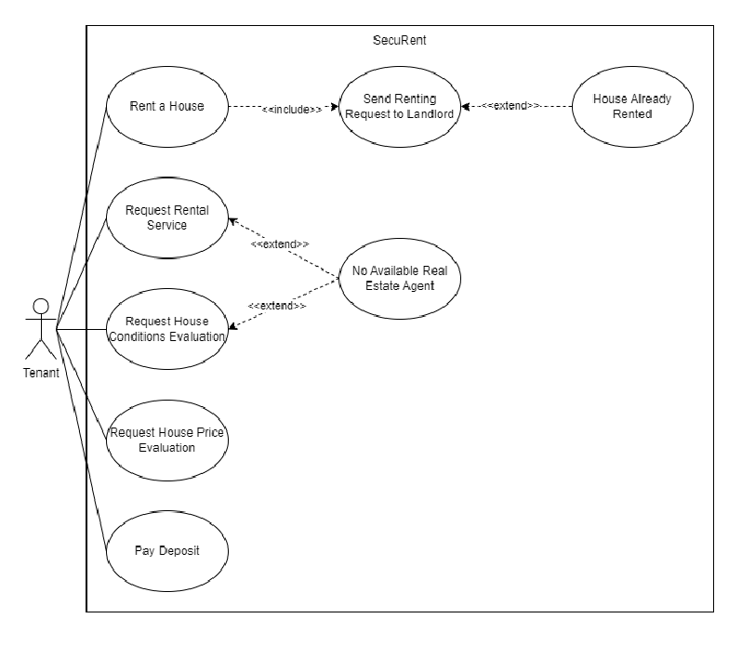

Figure 3: Use case for Tenant

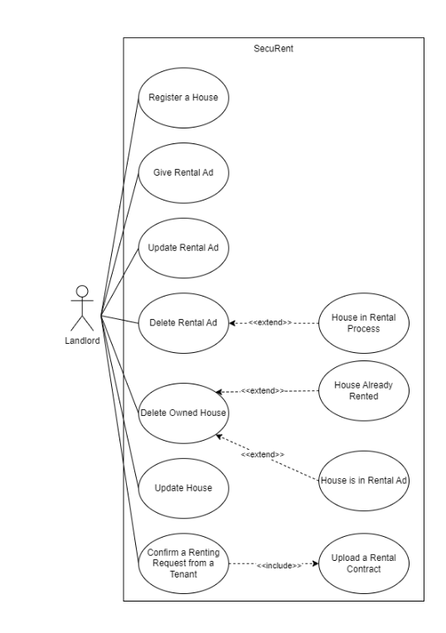

Figure 4: Use case for landlord

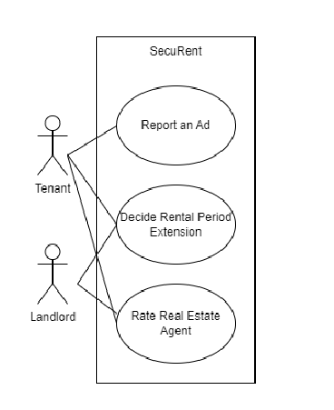

Figure 5: Common cases for tenant and landlord

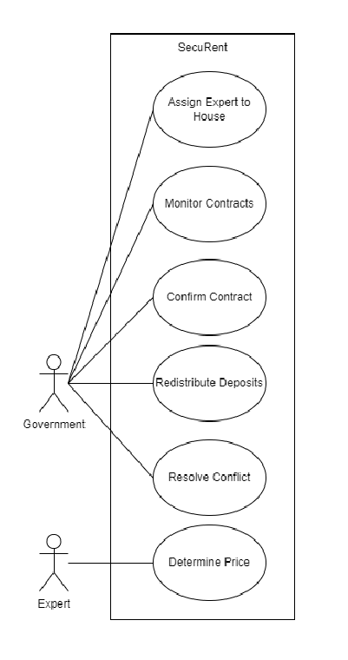

Figure 6: Common cases for expert and government

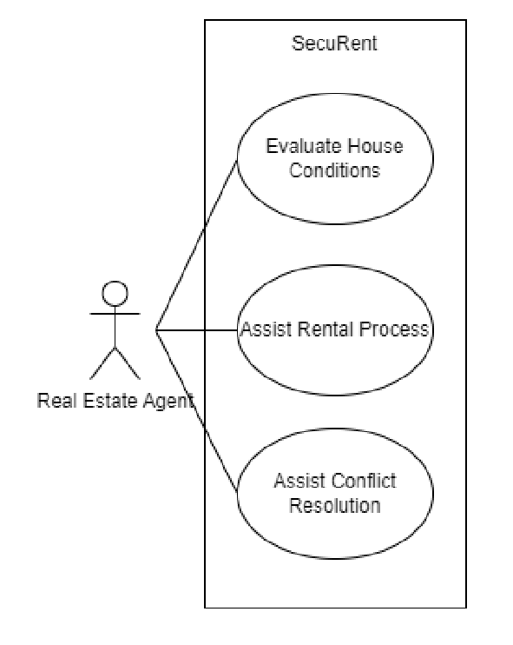

Figure 7: Use Case Diagram for real estate agent

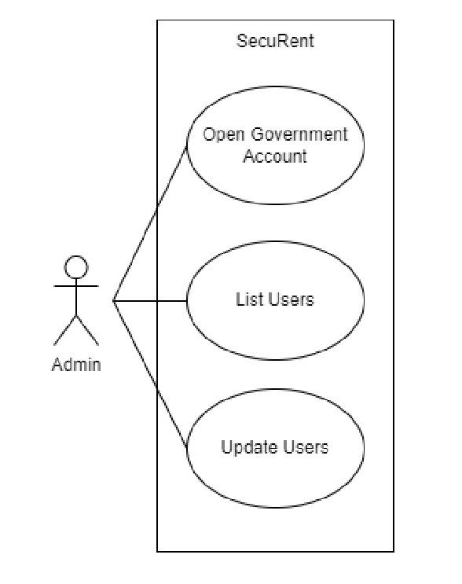

Figure 8: Use Case Diagram for admin

### 

### 

### 

### 

### 

### **3.5.3** **Object and Class Model**

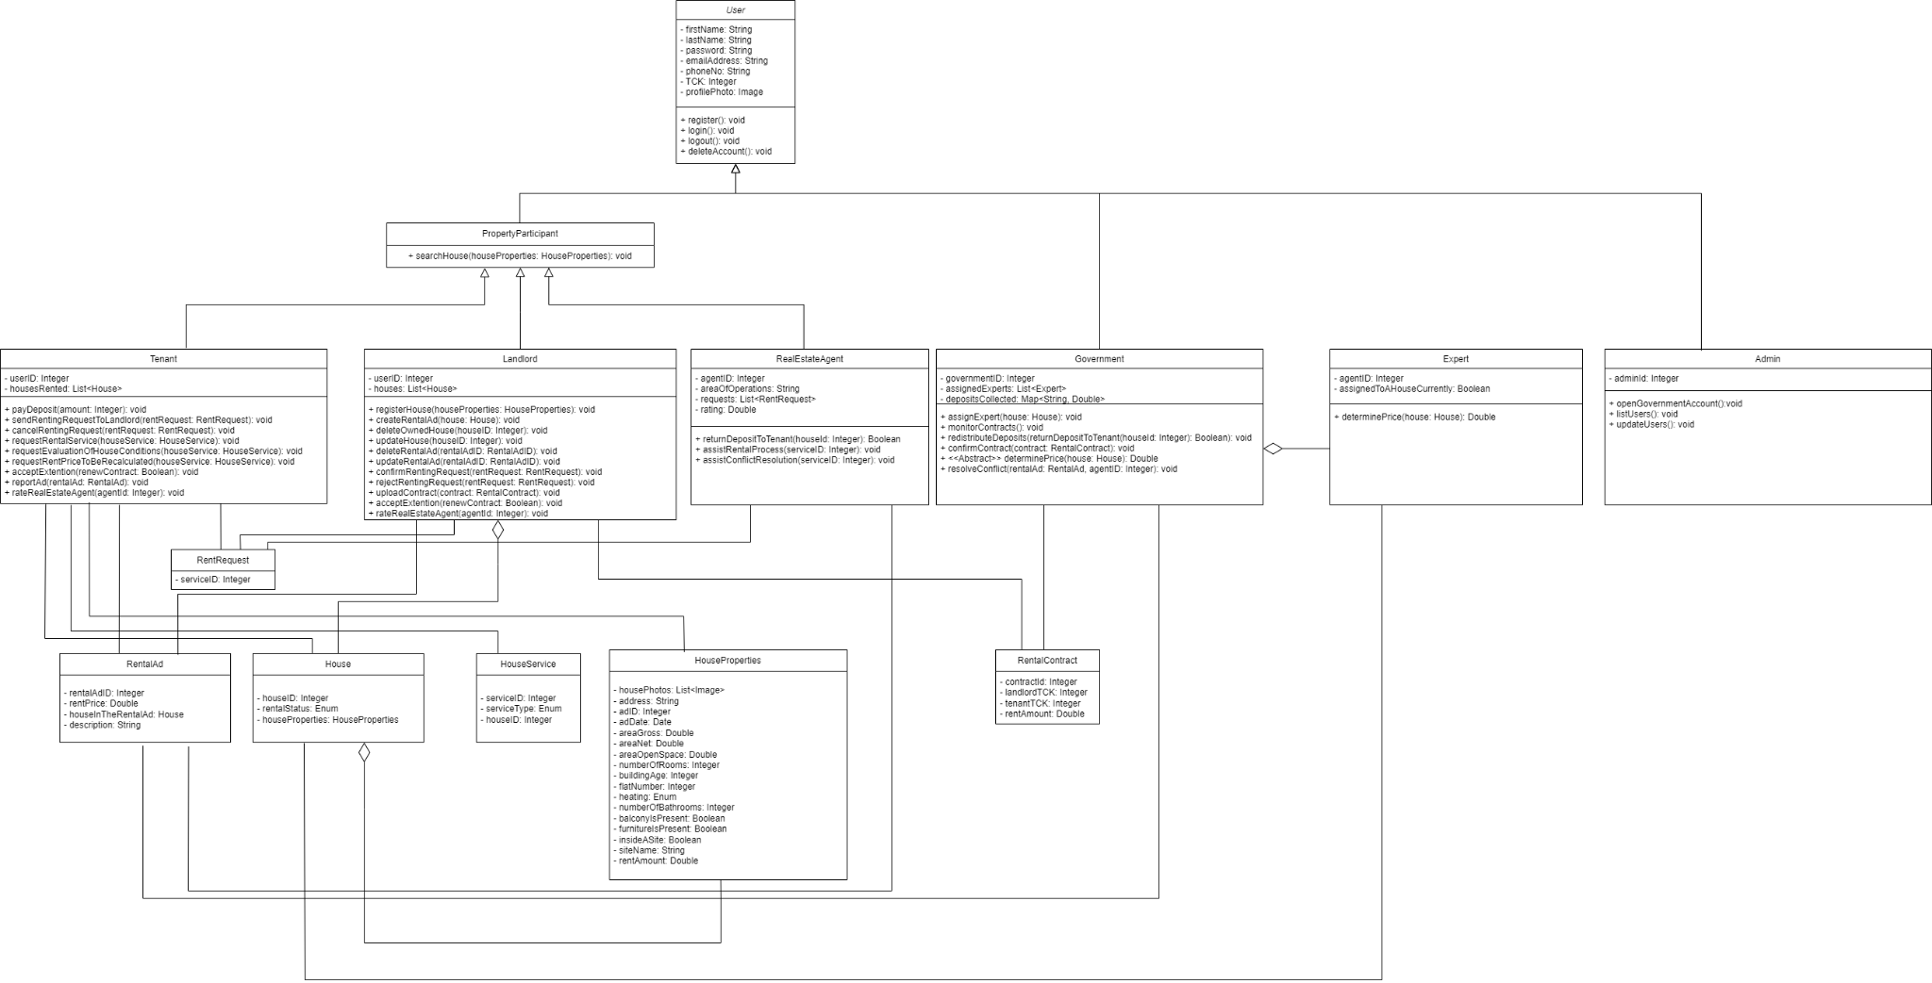

Figure 9: Class Model of the project

### 

| **Class** | **Description** |
| --- | --- |
| **User** | Base user of the system. Contains the credentials needed to create a user profile. Can register, login, logout, and delete the account. |
| **PropertyParticipant** | Parent class of the tenant, landlord and real estate agent classes. Can search a house. |
| **Tenant** | Class for the tenant role. Can pay the deposit, request house service (evaluation of price, evaluation of house conditions, rental service for a house), accept extension and report a rental ad (if there is a mismatch between the rental ad and the real house conditions such as mismatch in the number of rooms). Can rate the real estate agent after his/her service. |
| **Landlord** | Class for the landlord role. Can register a house and create a rental ad for the respective house. Can delete or update the house. Can delete and update the rental ad of a house. Can confirm the renting request of a tenant. Can upload a contract to the system, to be monitored by the government. Can rate the real estate agent after his/her service. |
| **RealEstateAgent** | Class for the real estate agent role. Can evaluate house conditions when a tenant contacts him/her upon the expiration of the contract. Hence, the deposit will be given to either the tenant or to the landlord depending on the evaluation of the real estate agent. Last but not least, real estate agents can assist the house renting process when requested. |
| **Government** | Class for the government role. Can assign experts to houses for the recalculation of the rent price, monitor contracts and store deposits. When the contract between a tenant and a landlord expires, the deposit amount will be redistributed to either one of the parties regarding the decision made by the real estate agent’s house condition evaluation. Can send a request to the landlord to resolve conflicts if there is a mismatch between what has been shared in the rental ad and what house has in real. |
| **Expert** | Class for the expert role. He/she can determine the rent price of an assigned house if the price recalculation request has been made by the tenant. |
| **Admin** | Class for the admin role. Can open an account for the government, list users and edit their profiles. |
| **RentRequest** | Class for the rent requests. |
| **RentalAd** | Class for the rental ads. Contains the house instance, rent price and additional description for the house to be rented. |
| **House** | Class for the house. Contains house properties and rental status. Rental status has possibly three states: Unrented, pending, rented. |
| **HouseService** | Class for the services regarding the house. Contains an enum of 4 house service operations: Evaluation of house conditions by real estate agent, rental service for touring the house by real estate agent, assistance for conflict resolution by real estate agent, and rent price recalculation by the government. |
| **HouseProperties** | Class containing the house properties. Contains the address, building age, flat of the apartment etc. |
| **RentalContract** | Class containing the necessary information for a rental contract between a tenant and a landlord. |

### 

### 

### 

### **3.5.4** **Dynamic Models**

**Sequence Diagrams**

A sequence diagram is a type of interaction diagram in UML that shows how processes or objects within a system interact with each other over a certain period. It visually depicts the flow of messages or events between different components, actors, or objects in a system in a chronological order.

**Rent Process for tenant**

This sequence demonstrates how tenants rent a house. Tenants first must search a particular house, then select a house from the list of houses, then make a request.

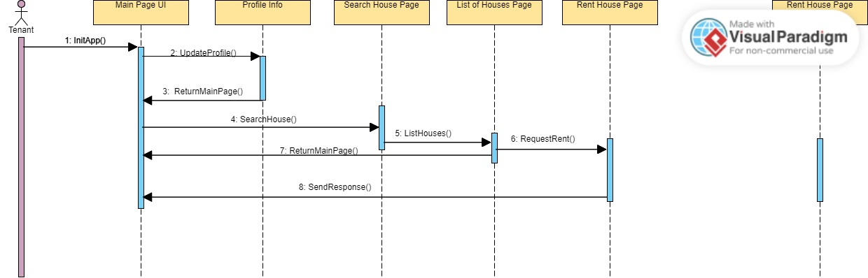

Figure 10: Sequence diagram for rent process

**Processes of government**

This sequence shows how the government functions. Government actor

sees the contacts, collects deposit and according to condition of the house return it

to the tenant or decide that the landlord keeps the deposit. Then, government can

review the prices of houses.

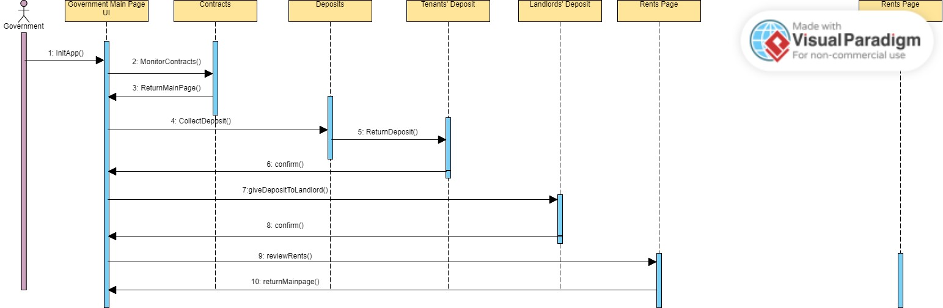

Figure 11: Sequence diagram government functions

**Activity Diagrams**

**Tenant Activity Diagram**

In addition to the sequence diagrams, main flow of the application is shown in the

Activity diagram below. This diagram demonstrates the main flow of events

instead of a specific flow of events. Entry point is the login of the client to the

application, and exit point is the logout. Events are displayed by the perspective of the tenant user.

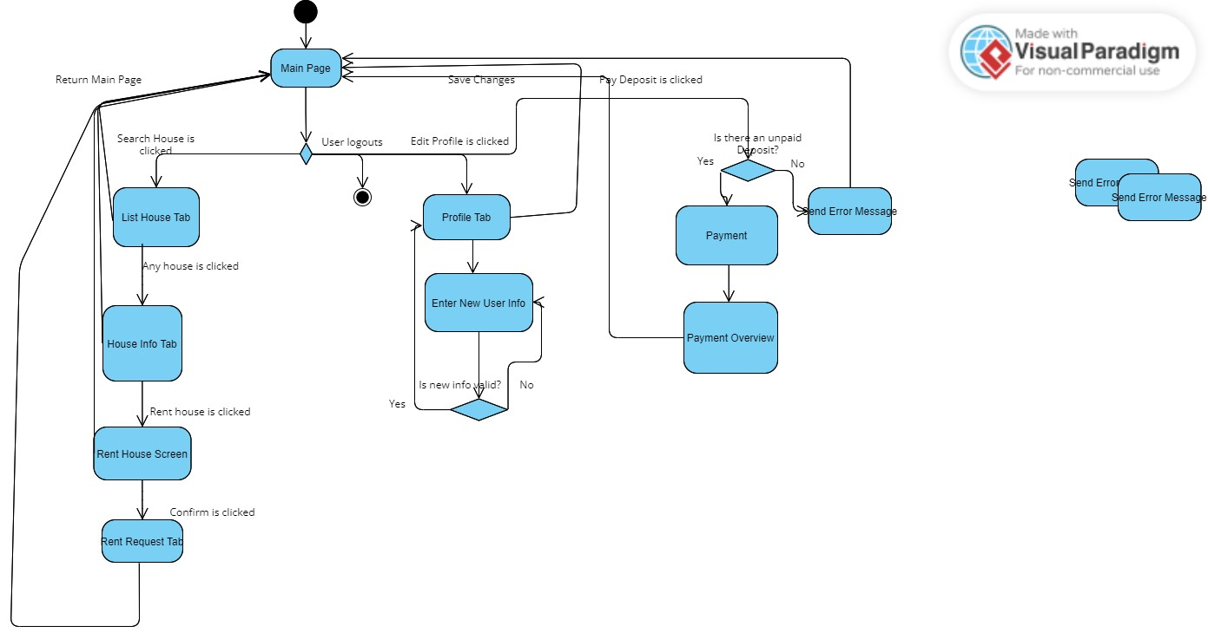

Figure 12: Activity diagram for tenant

**Landlord Activity Diagram**

This activity diagram represents the main activities of the landlords. Landlord’s activities are to update the house, delete the house, accept or decline the rental request. They can also edit their profiles and search houses just like any other user.

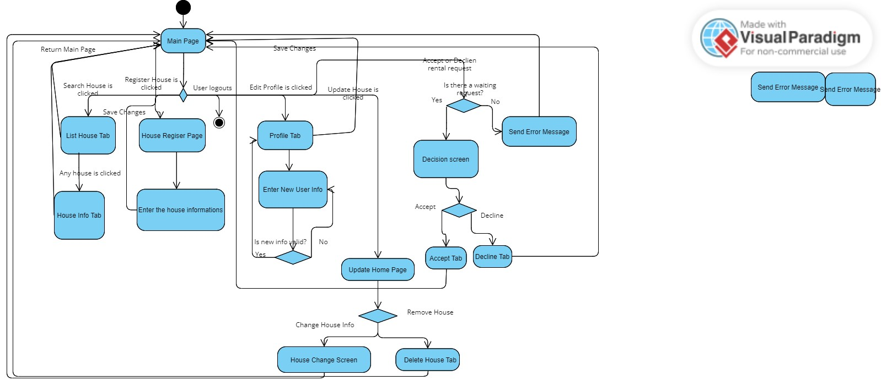

Figure 13: Activity diagram for landlord

### **3.5.5** **User Interface**

#### 3.5.5.1 Login Page:

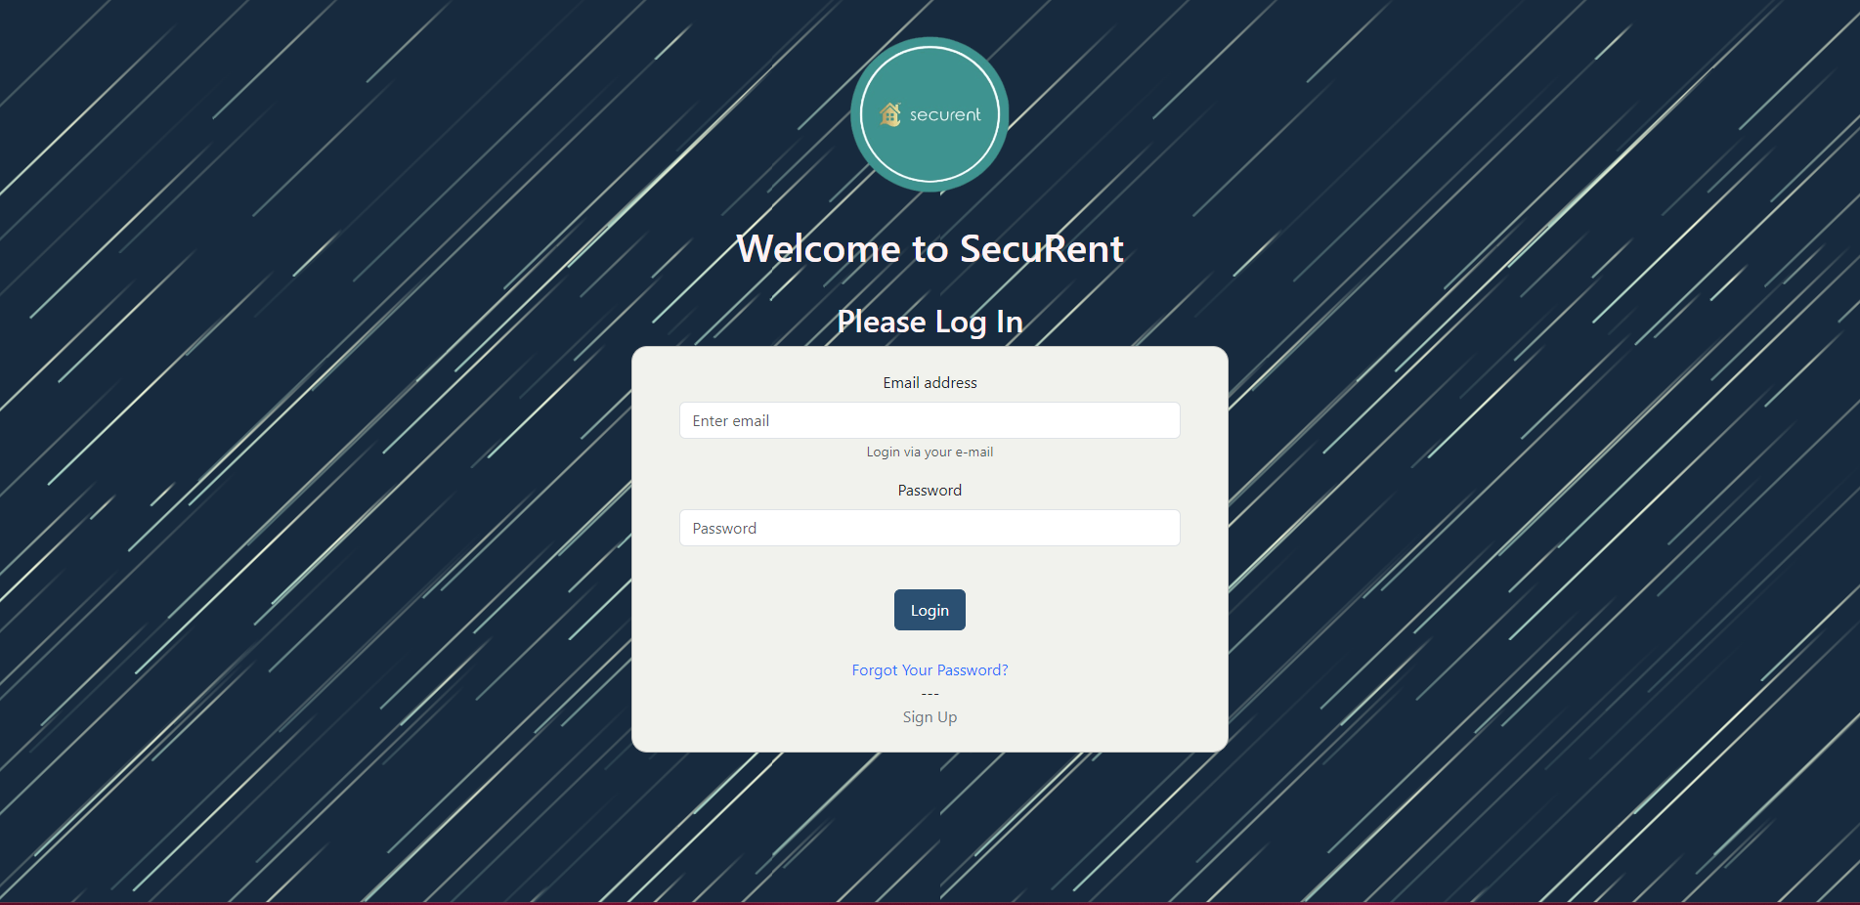

Figure 14: Login Screen interface

For each actor, the login screen will be the same. It asks for email address and password, also it can direct the users to Forgot Your Password or Sign Up.

#### 3.5.5.2 Forgot Your Password:

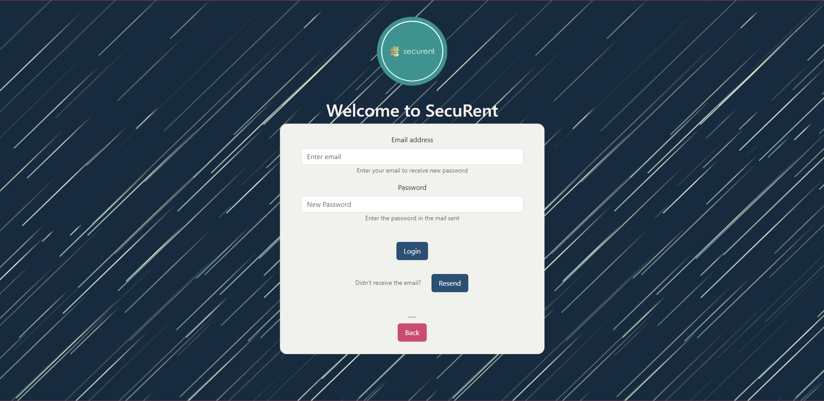

Figure 15: Forgot Password interface

Forgot your password basically uses a mail API and makes the user change their password through mail confirmation. They can also resend the new password to themselves if needed.

#### 3.5.5.3 Sign Up:

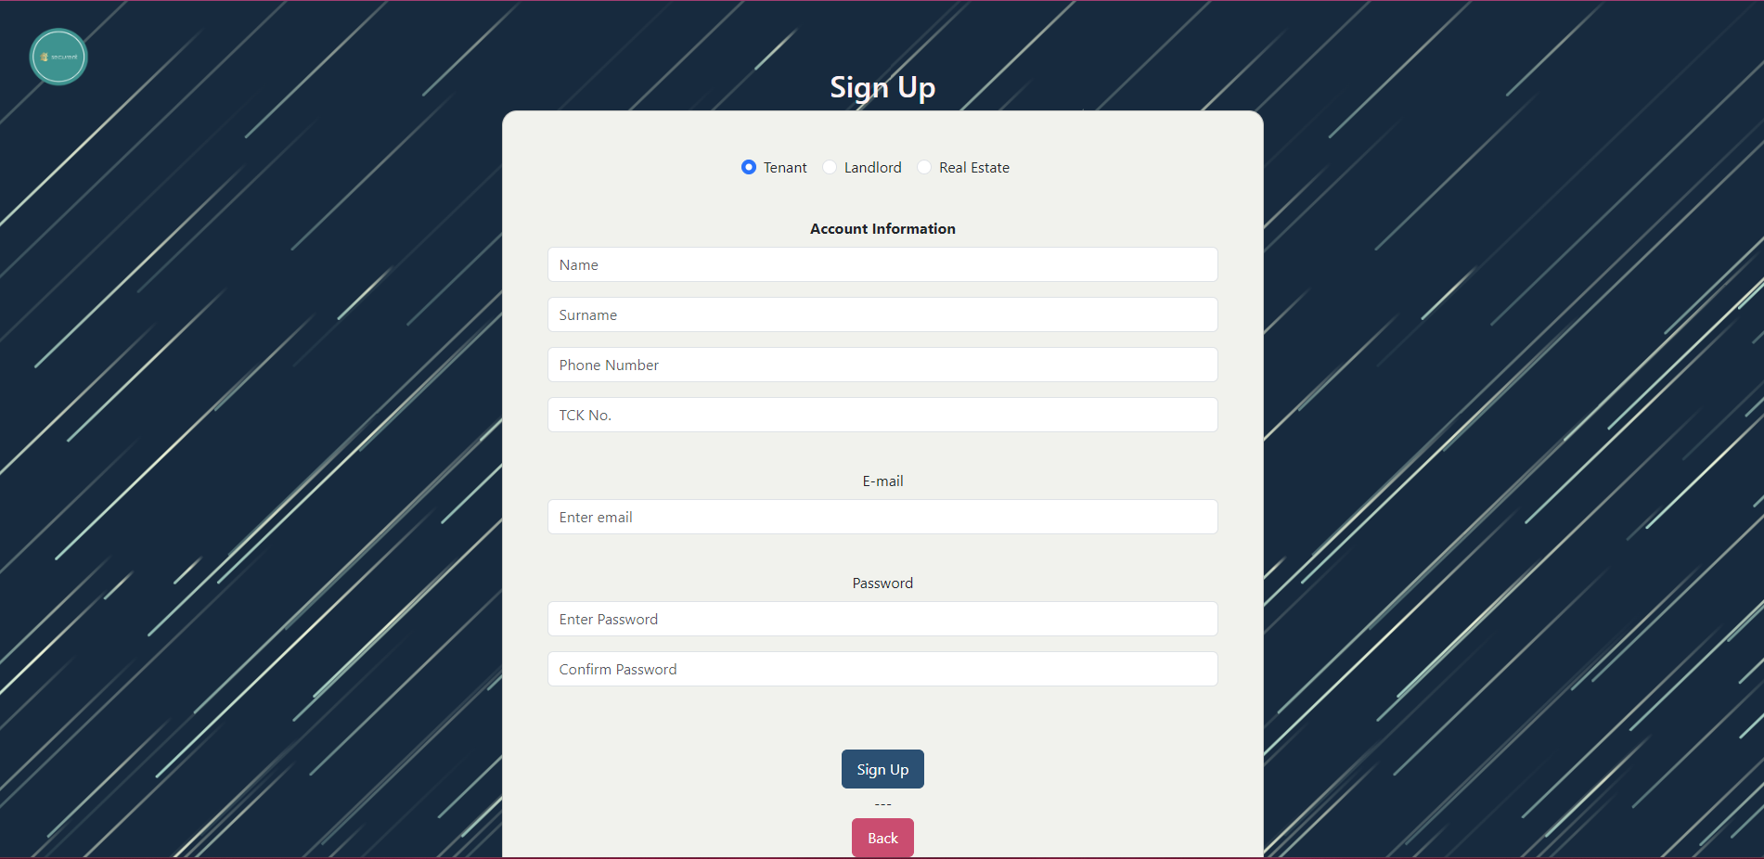

Figure 16: Sign Up interface

This page is for signup, and the users can pick their account type through the radio button at the top. They will submit their name, surname, phone number, TCK number, and mail addresses.

#### 3.5.5.4 State Official (Government) Home Page:

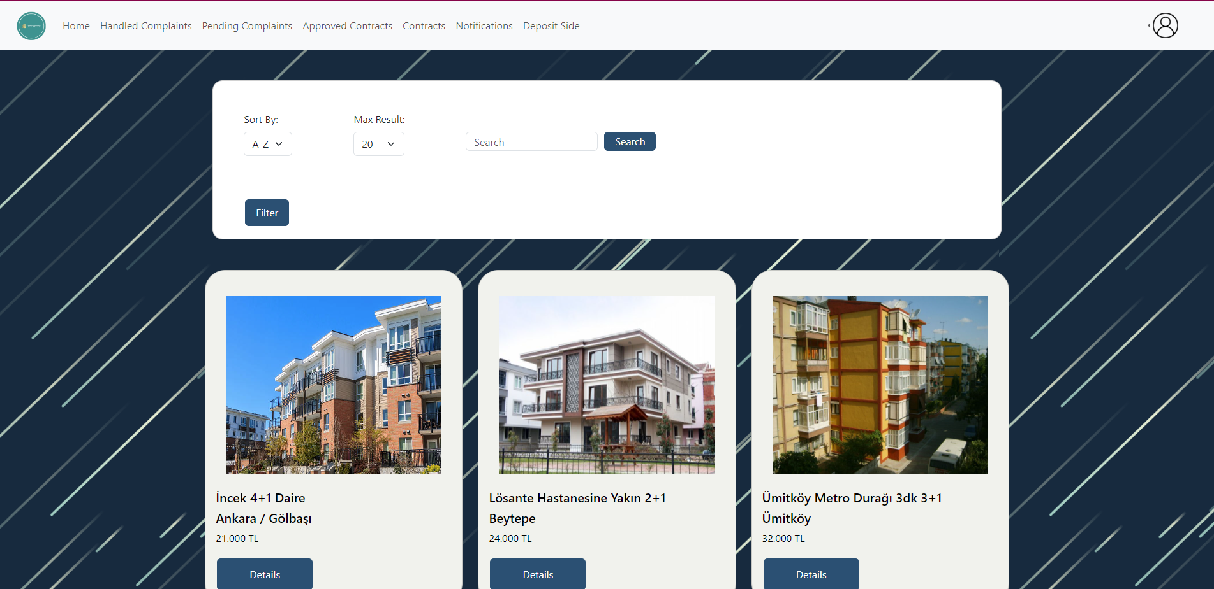

Figure 17: State Official Home Page:

This is the home page for state officials. They will be able to view the ads based on their locations only. They can also apply filters or directly search for any type of an ad.Their navigation bar includes: Home, Handled Complaints, Pending Complaints, Approved Contracts, Contracts, Notifications, Deposit Side.

#### **3.5.5.5 State Official Profile:**

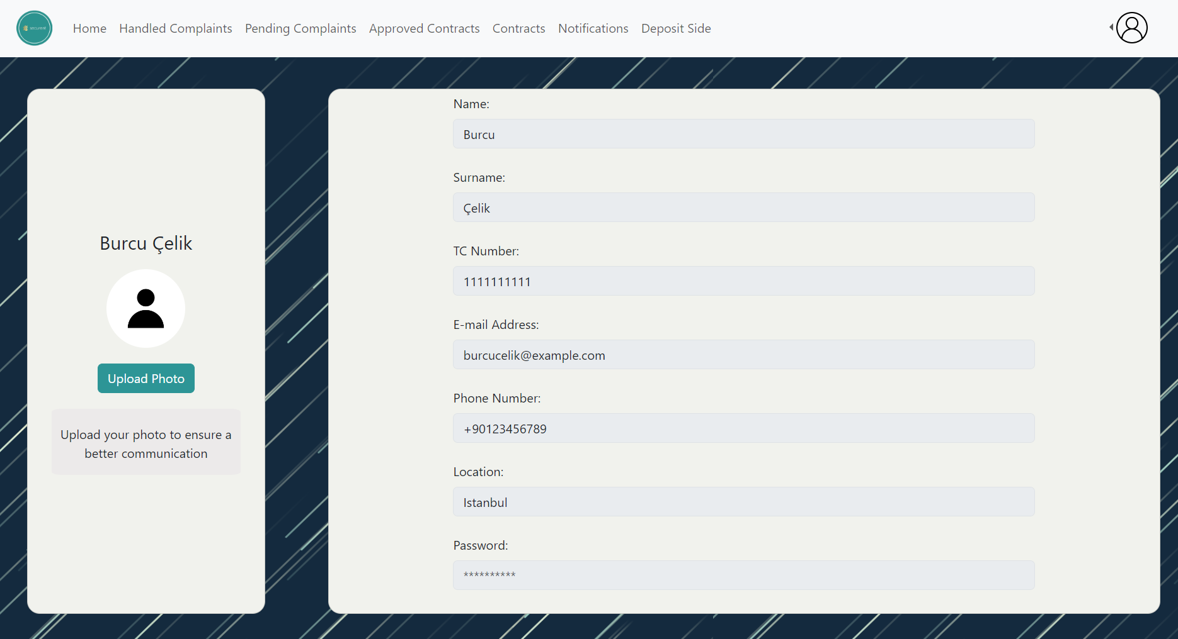

Figure 18: State Official Profile

Information of state officials such as name, surname, TC number, e-mail address, phone number is displayed on this page. The password is censored. Users can also see her/his profile picture and edit the profile picture. If the user does not upload any profile picture, the default one is shown.

#### 3.5.5.6 Deposit Side:

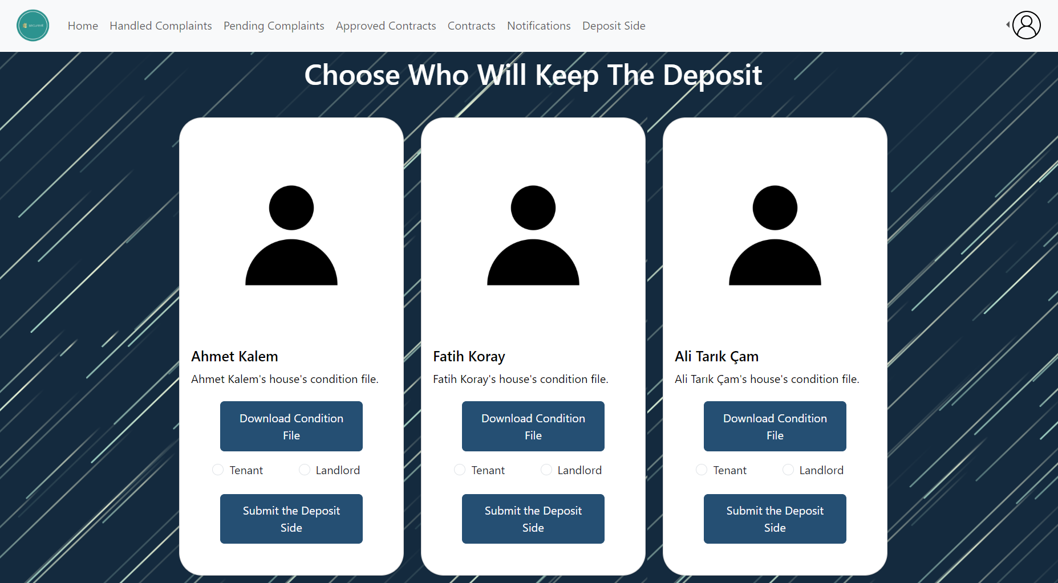

Figure 19: Deposit Side interface

State officials can download the condition file uploaded by the real estate agents and decide who will keep the deposit money on this page.

#### 3.5.5.7 Contracts:

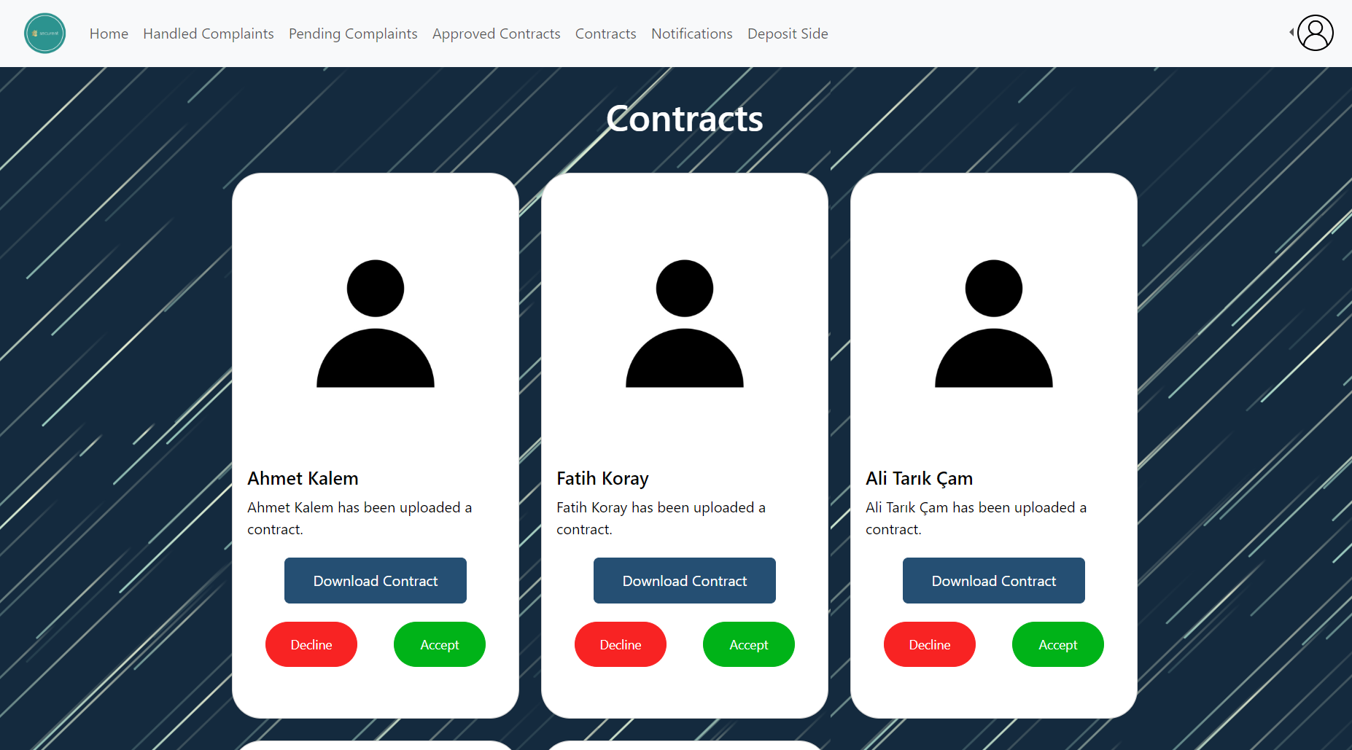

Figure 20: Contracts interface

To be able to rent a house in the system, the renting operation must be approved by the state officials. In this page, state officials can download the contract uploaded by the landlords and either decline or accept the renting process.

#### 3.5.5.8 Approved Contracts:

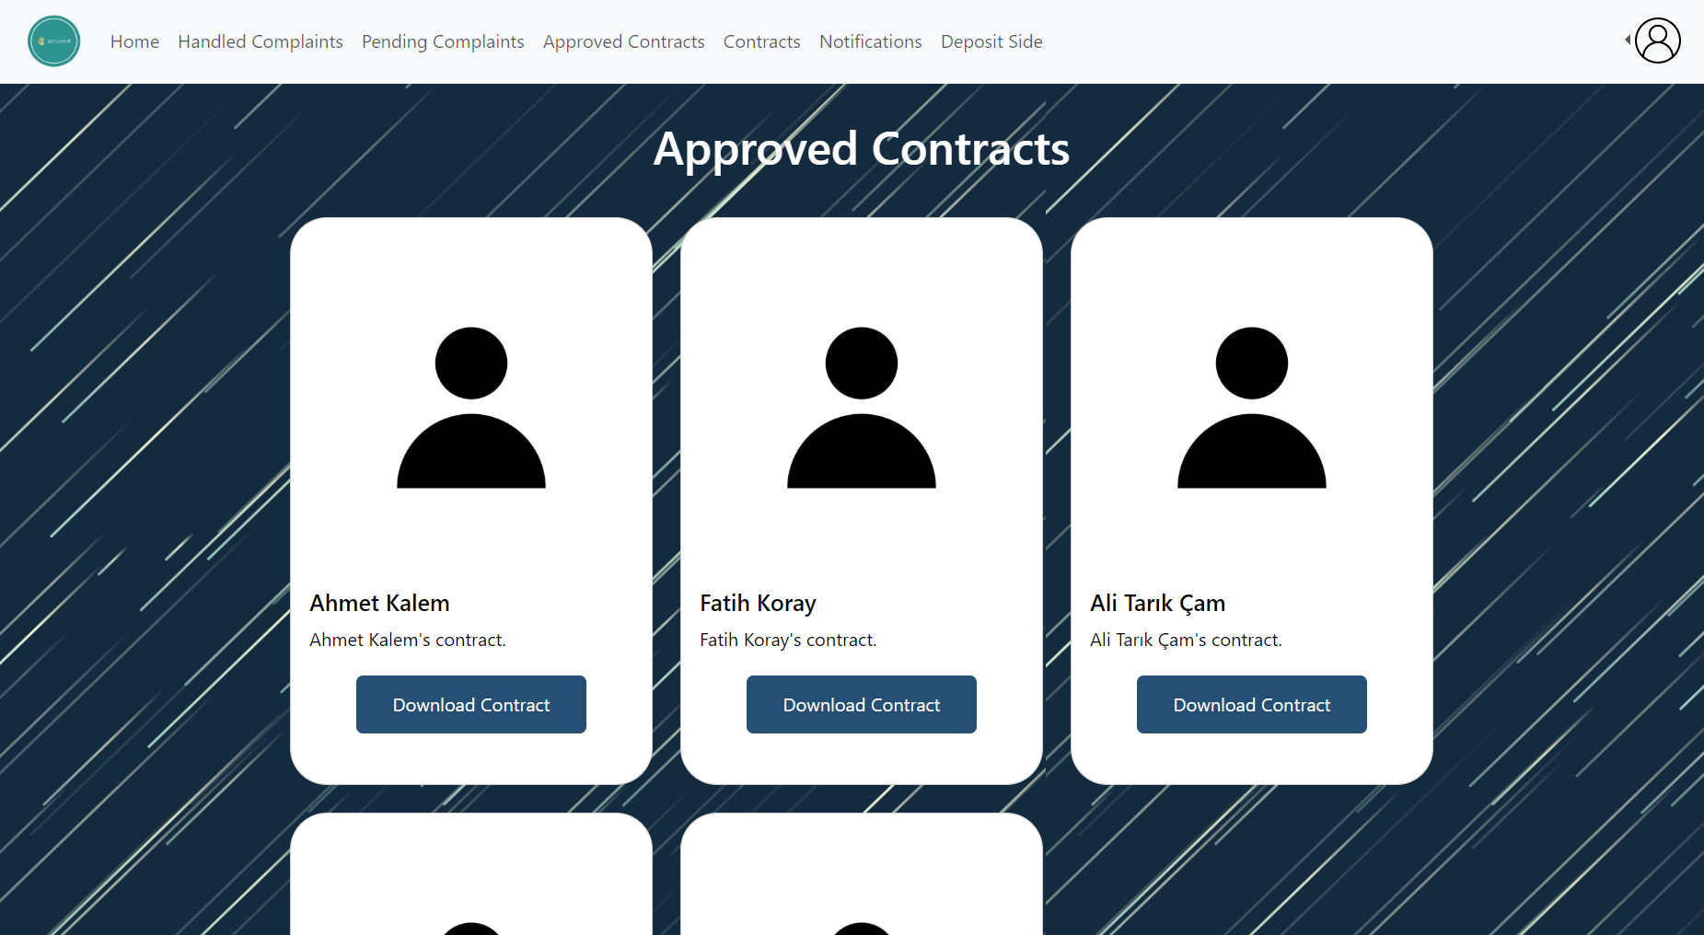

Figure 21: Approved Contacts Interface

On this page, approved contracts by the state official are displayed. State officials can also download the contracts.

#### 3.5.5.9 Complaint Notifications:

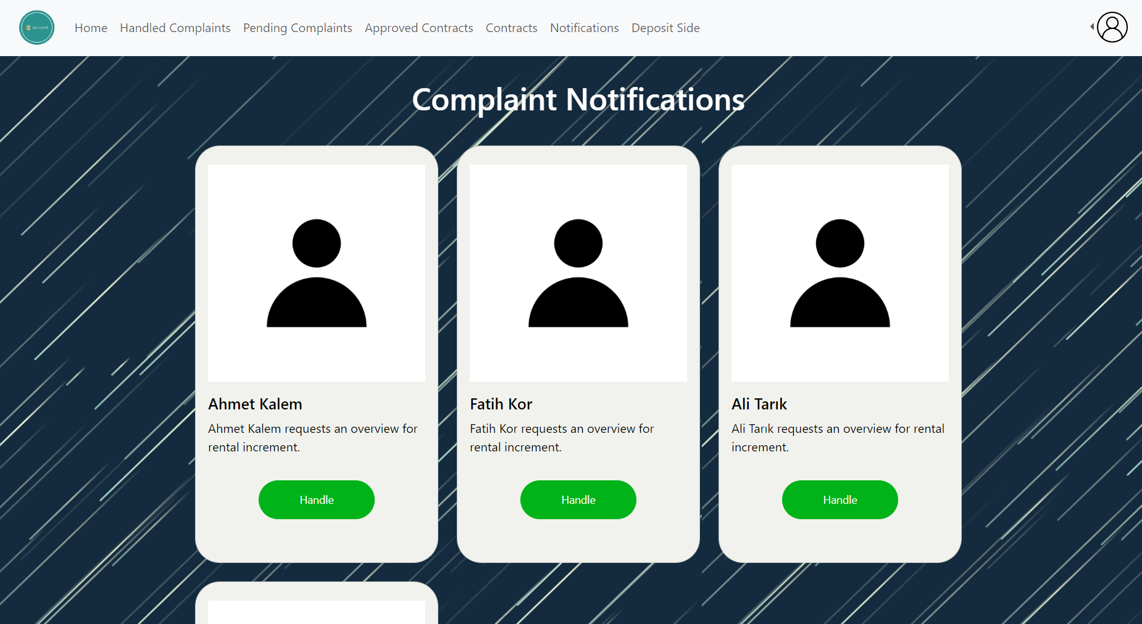

Figure 22: Complaint Notifications: Interface

On this page complaints that are made by tenants are displayed. State officials need to click the handle button to assign somebody to investigate the problem. When the handle button is clicked, the complaint moves to the pending complaints page.

#### 3.5.5.10 Handled Complaints:

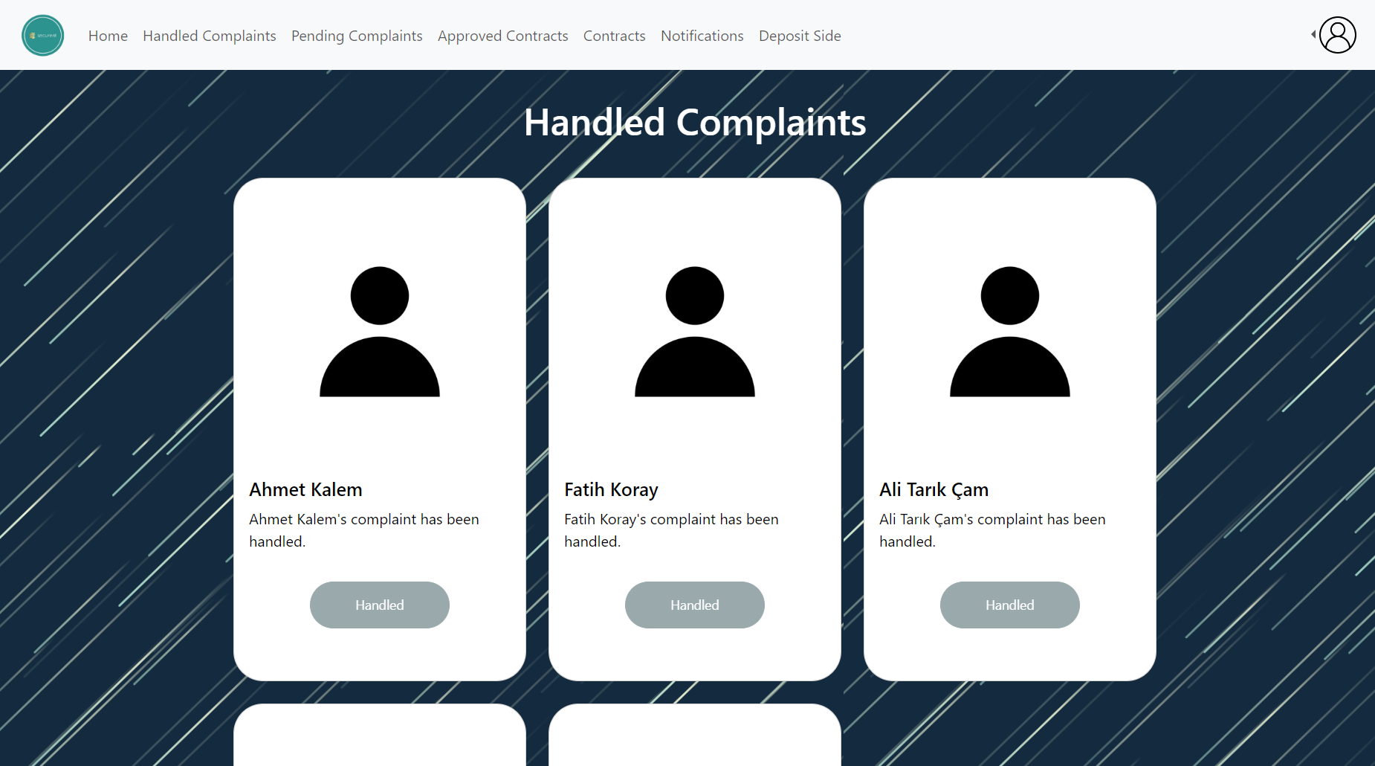

Figure 23: Handled Complaints interface

Previously handled complaints take place on this page.

#### 

#### 3.5.5.11 Pending Complaints:

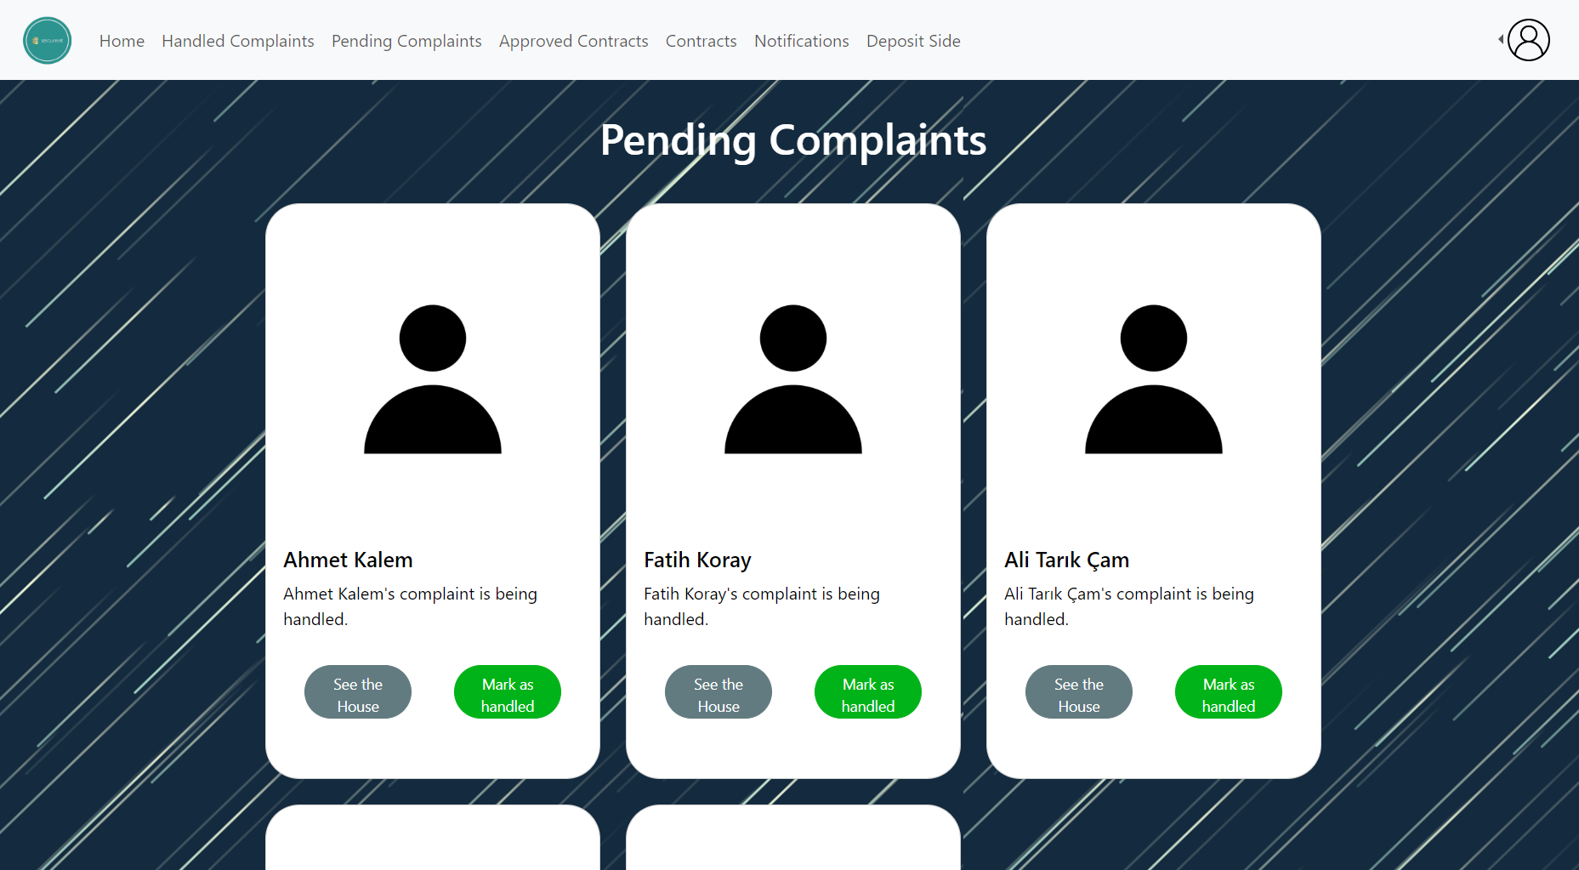

Figure 24: Pending Complaints interface

State officials can see the pending complaints on this page. When the problem is solved, they click mark as handled button to carry the complaint to “Handled Complaints” page. They can also display the house in which the complaint occurred.

#### 3.5.5.12 Tenant Home Page:

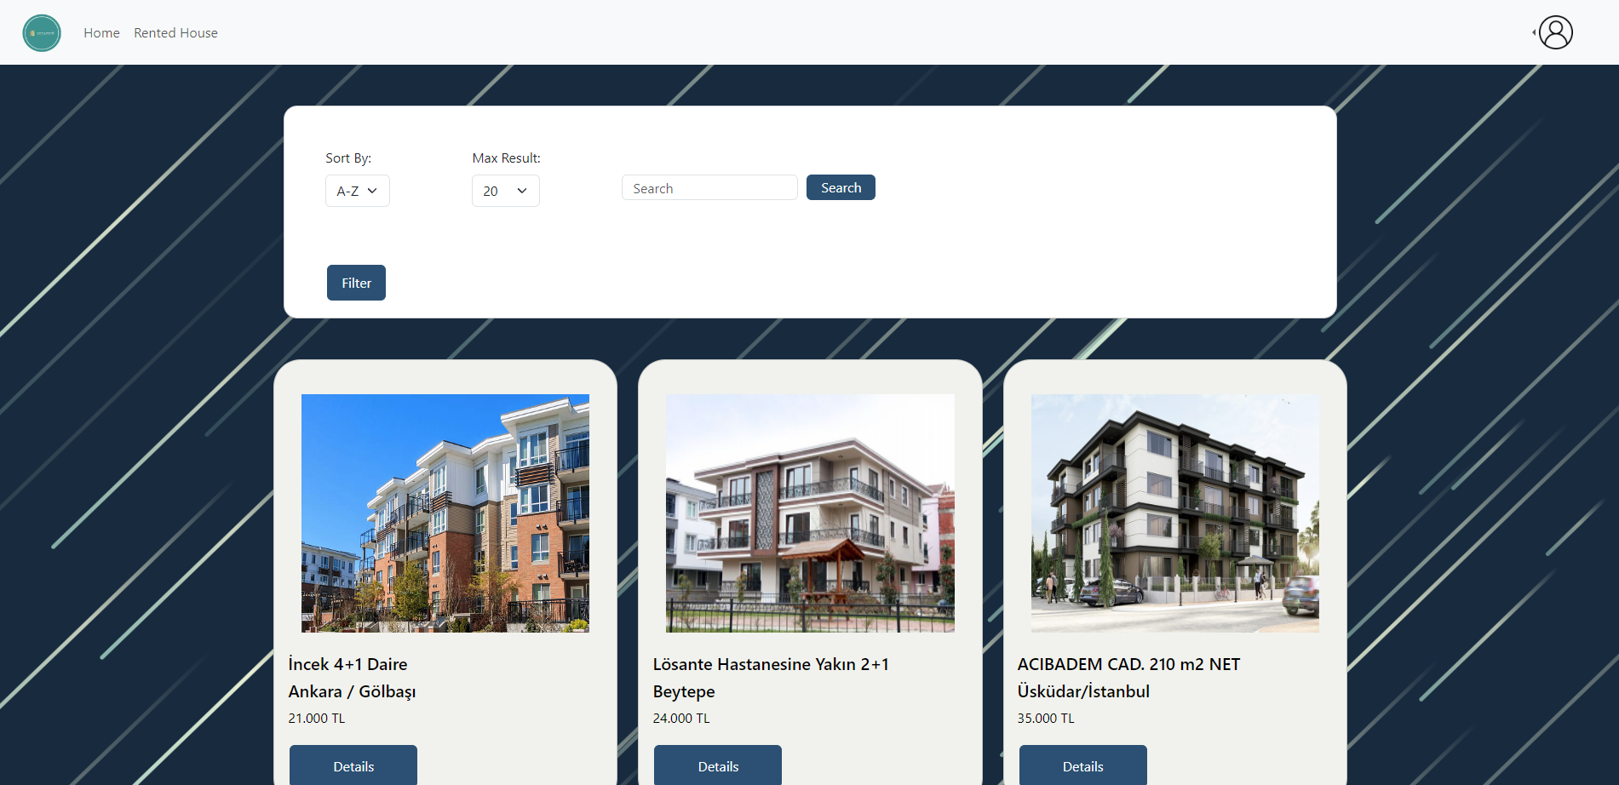

Figure 25: Tenant home page

This is the home page for tenants. They can view any ad regardless of their location (city). They can apply filters to the results if necessary, and search for any specific ad. Their navigation bar includes: Home, and Rented House.

#### 3.5.5.13 Tenant Ad Details:

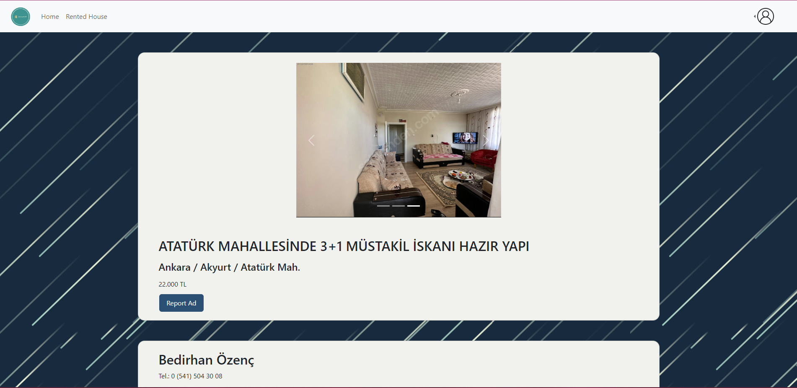

Figure 26: Tenant ad details interface

In this page, tenants can view the specifics of the ad. They can look for the photos uploaded for an ad.

#### **3.5.5.14** Tenant Ad Details (Cont’d):

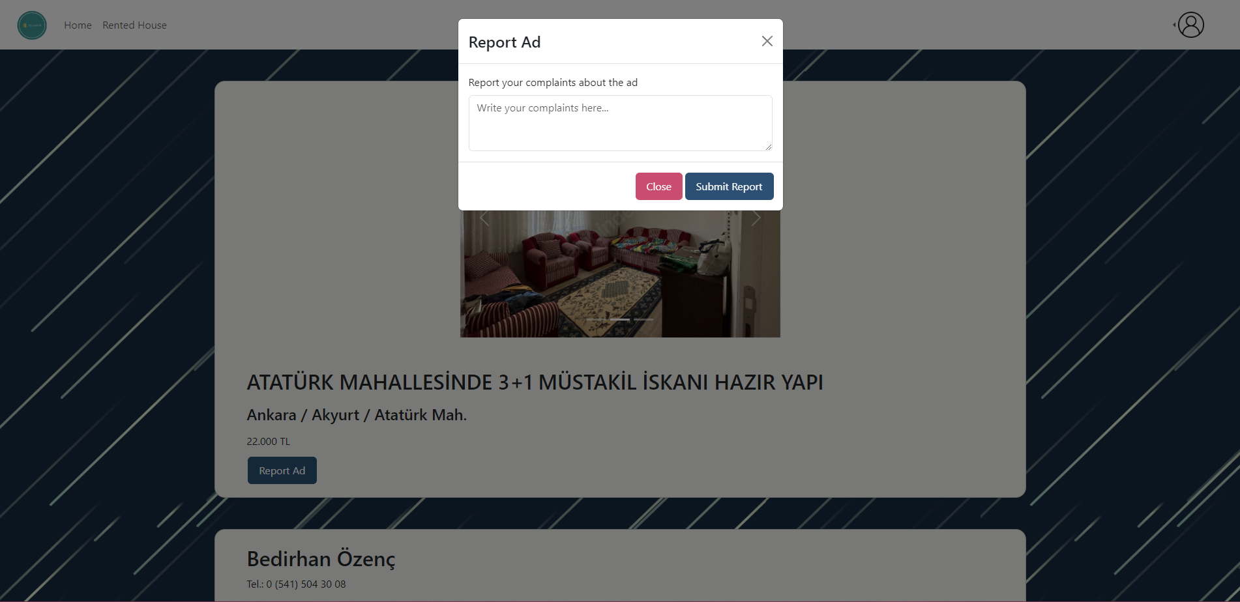

Figure 27: Tenant ad details interface (Cont’d)

Tenants can report the ad for any inconveniences (i.e. if the ad does not comply with government regulations or if a tenant is to send a price determination request).

#### **3.5.5.15** Tenant Ad Details (Cont’d):

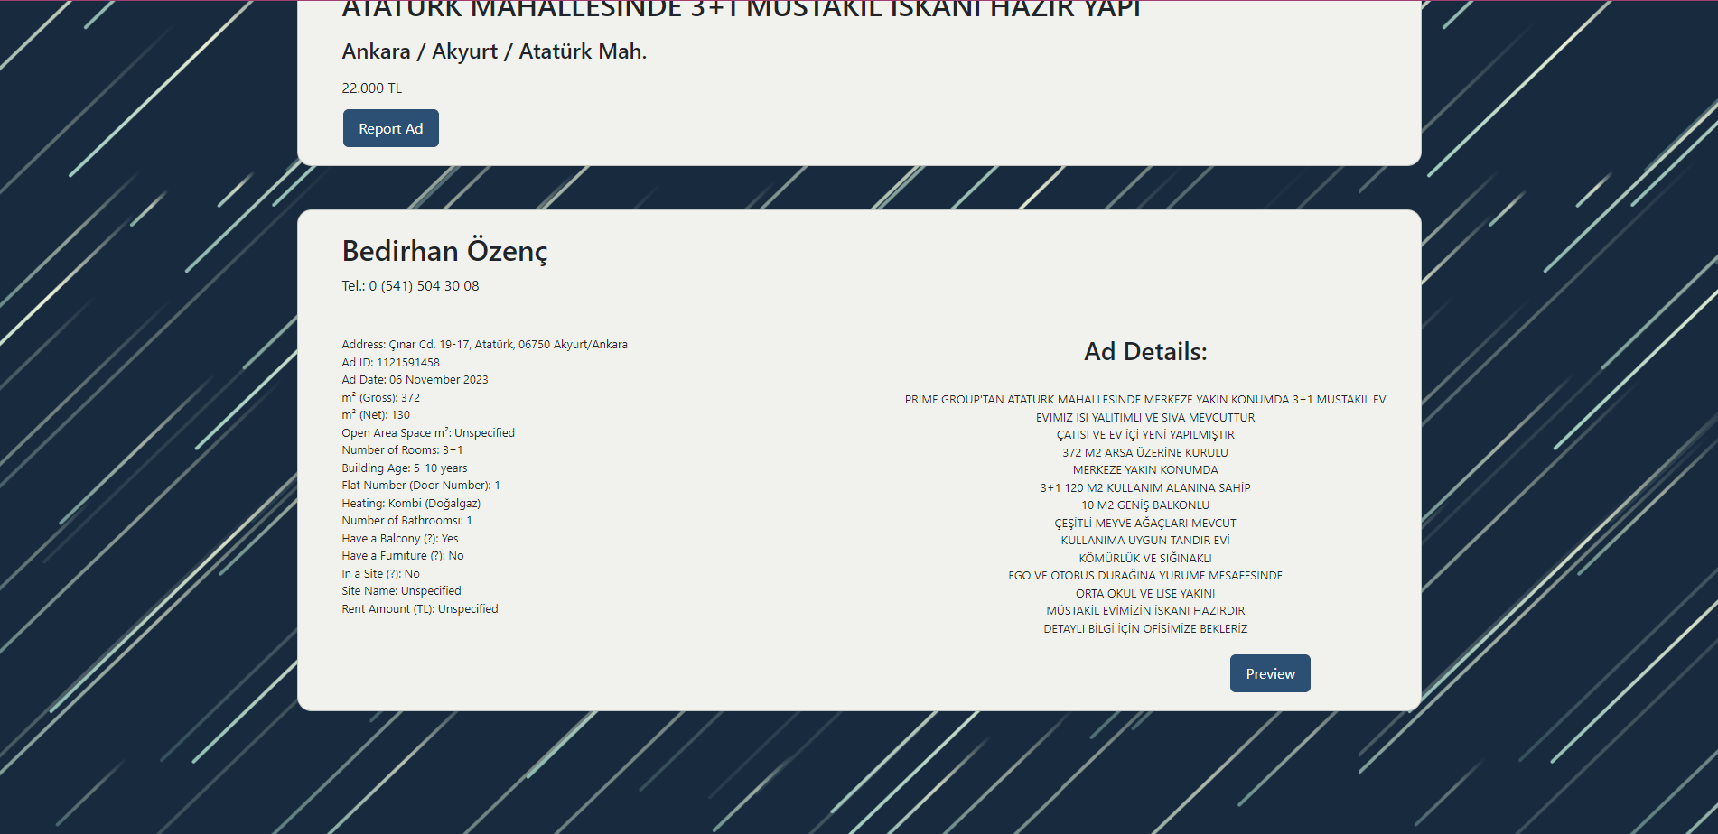

Figure 28: Tenant ad details interface (Cont’d)

Below the main banner, there resides more details for an ad, which are directly specified by the publisher (landlord). They can preview the list of real estate agents for the ad through the button “Preview” at the bottom.

#### 3.5.5.16 Tenant Profile:

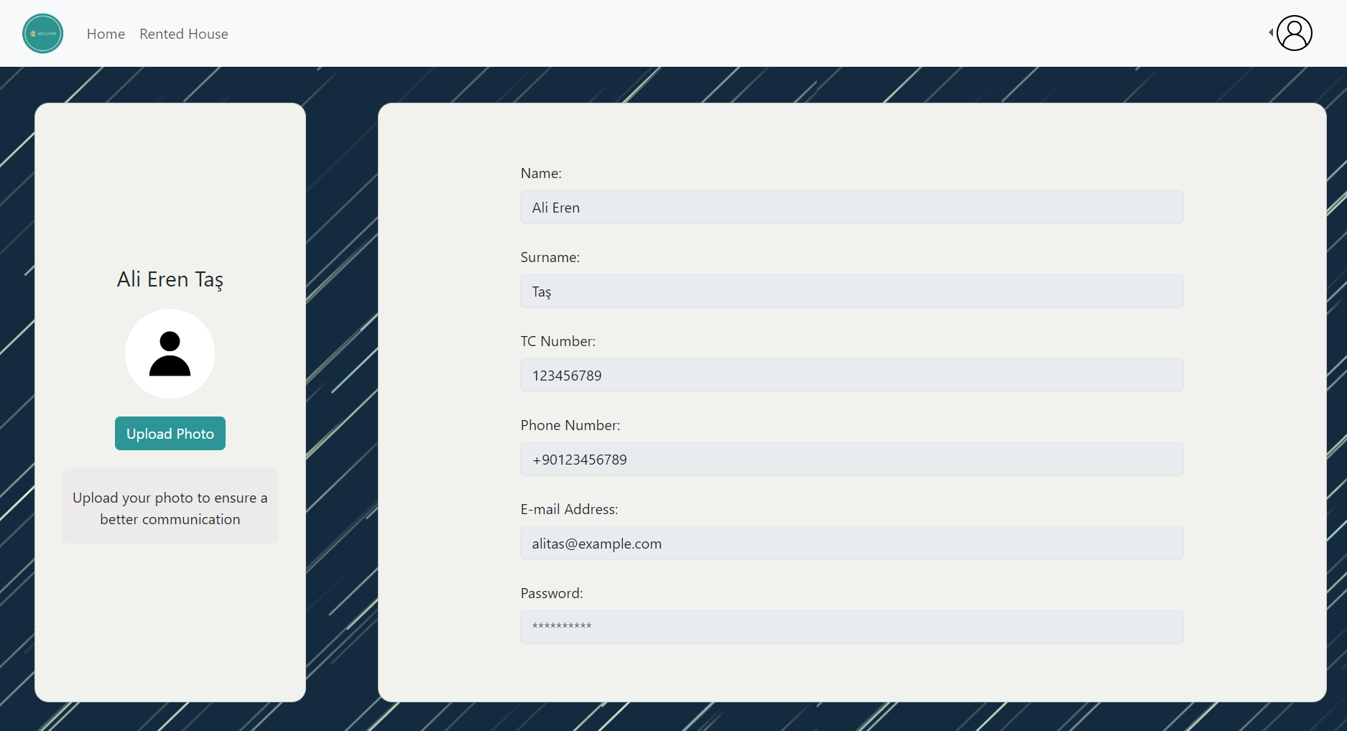

Figure 29: Tenant profile page

Information of the tenant such as name, surname, TC number, e-mail address, phone number is displayed on this page. The password is censored. Users can also see her/his profile picture and edit the profile picture. If the user does not upload any profile picture, the default one is shown.

#### 3.5.5.17 Rate Real Estate Agent for Tenant:

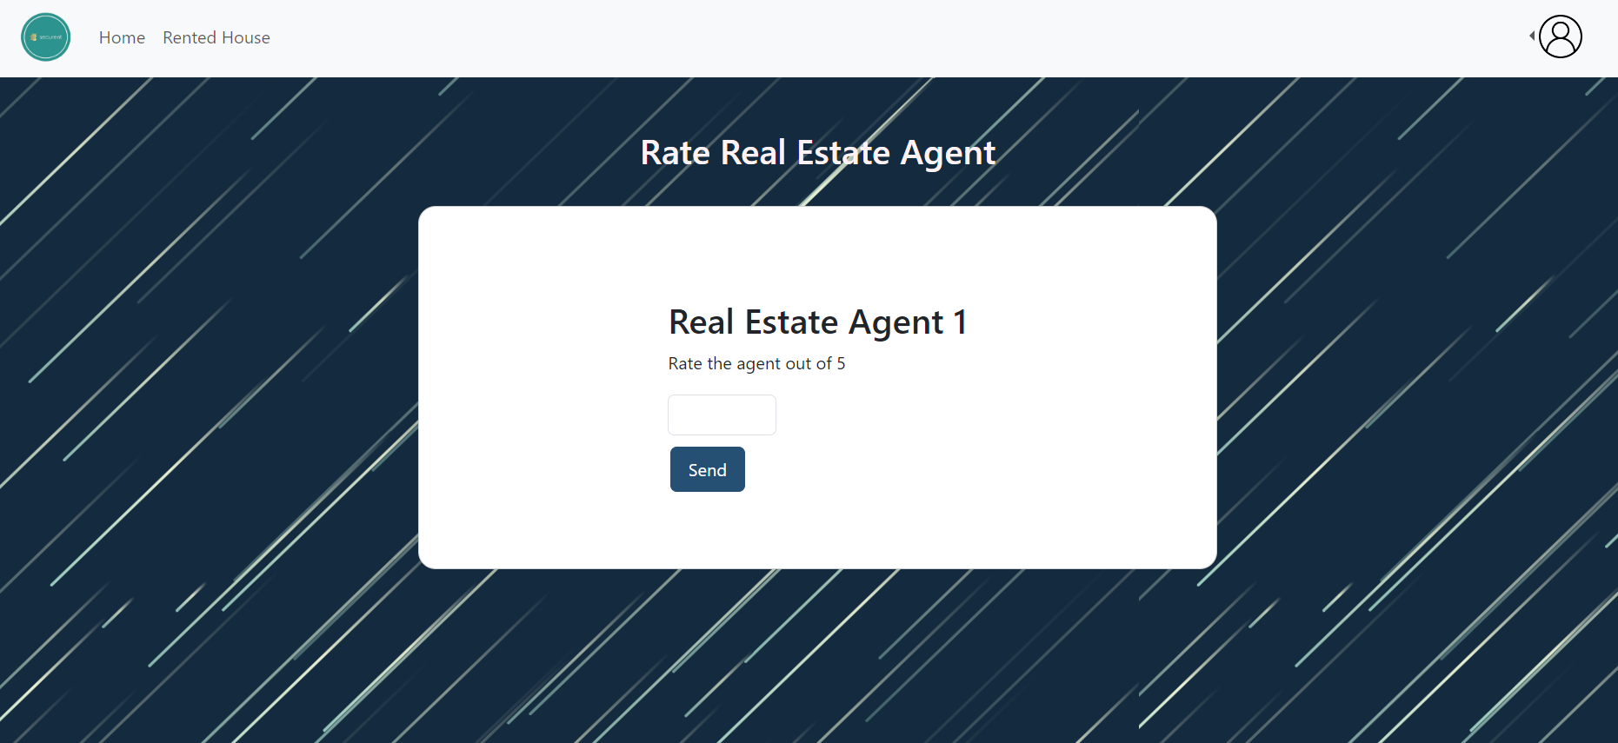

Figure 30: Rate Real Estate Agent for Tenant page

After the touring process ends, tenants need to rate the real estate agent. Rating will be done out of 5.

#### 3.5.5.18 Rented House:

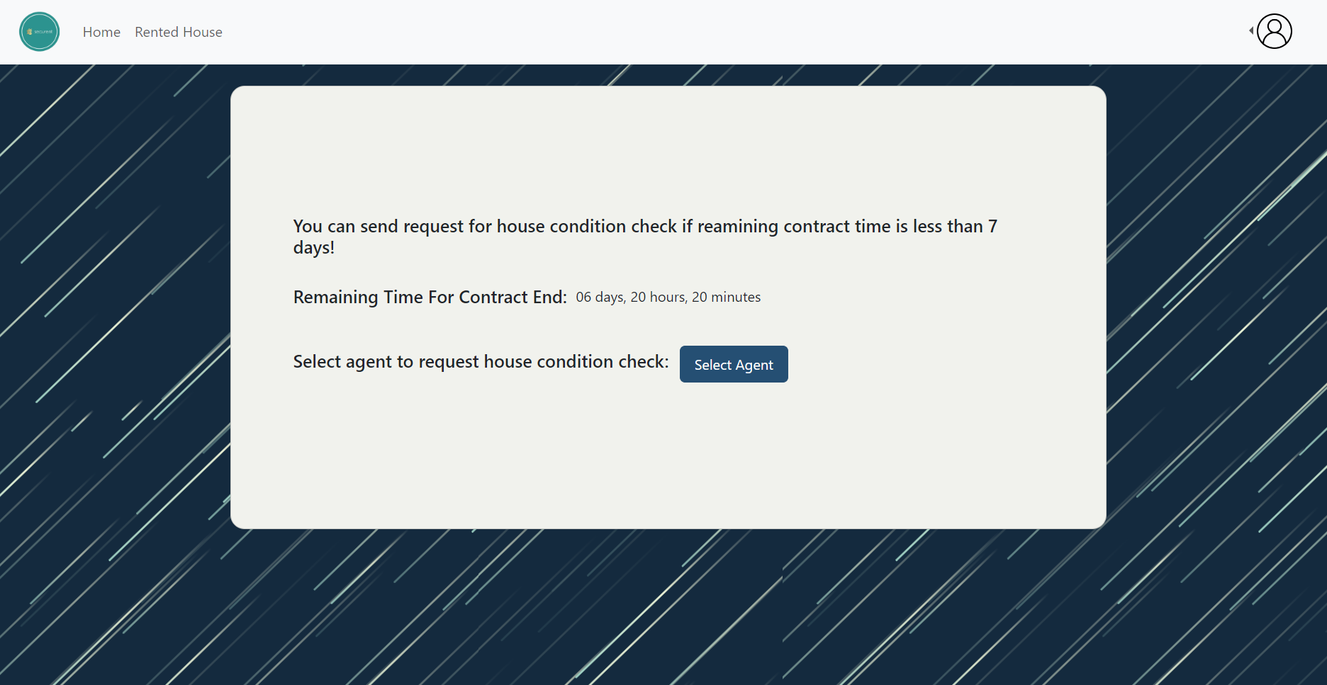

Figure 31: Rented house interface

On this page, the tenant can select a real estate agent for a house condition check to determine who will keep the deposit. When the select agent button is clicked, the user will be directed to the “Select Agent” page.

#### 3.5.5.19 Select Agent:

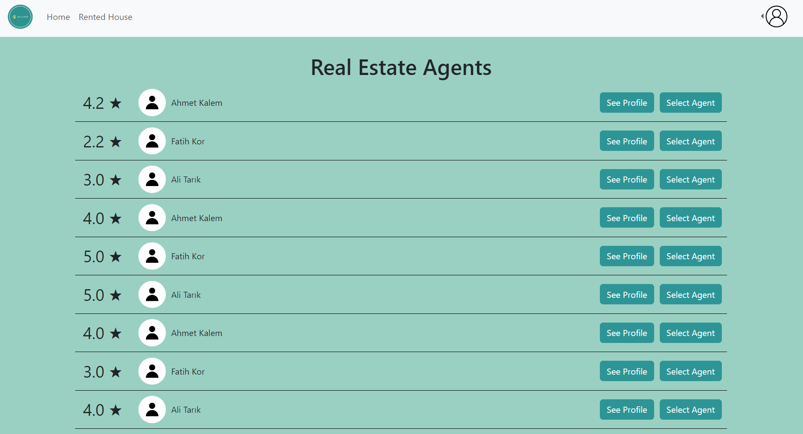

Figure 32: Select agent interface

When the tenant wants to see a house physically, they must do it by choosing a real estate agent in the area. Tenants can display the available real estate agents in the area. They can see real estate agents’ profiles and select the real estate agent to go for a tour.Also, real estate agents’ profile photos , names and rankings can be shown on this page.

#### 3.5.5.20 Landlord Publish Ad:

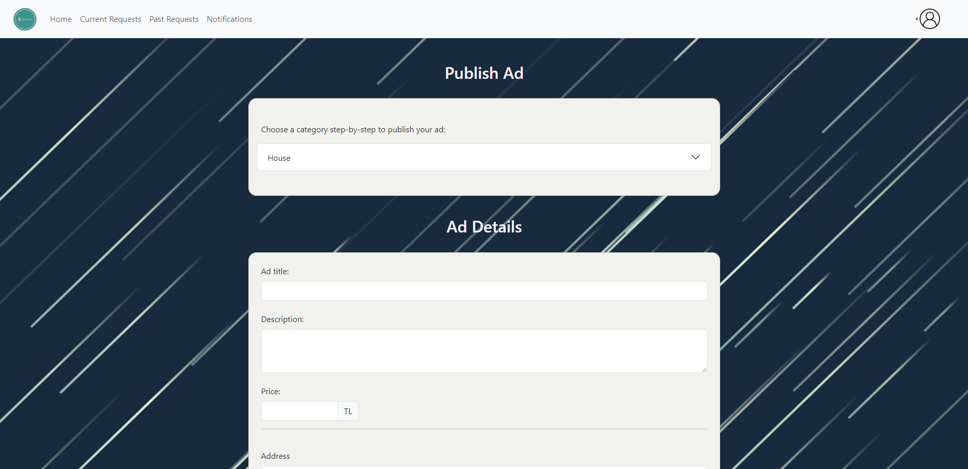

Figure 33: Landlord Publish Ad interface

At the beginning, the landlord chooses the type of the rental through accordions.

#### 3.5.5.21 Landlord Publish Ad (Cont’d):

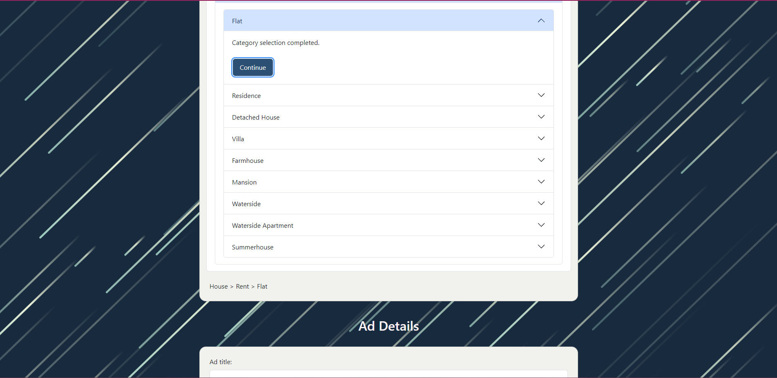

Figure 34: Landlord Publish Ad interface (Cont’d)

When they select any rental, the selection of the category is dynamically written beneath the accordions.

#### 3.5.5.22 Landlord Publish Ad (Cont’d):

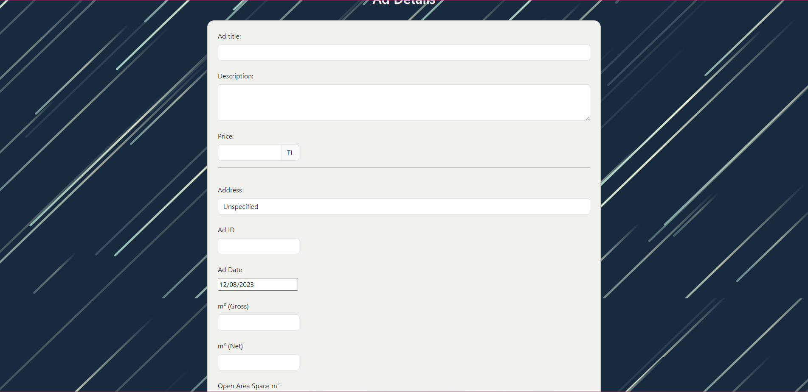

Figure 35: Landlord Publish Ad interface (Cont’d)

Next, the landlords can enter the specific details of ad title, description and the price of the ad. After that, they enter the Address of the ad, Ad ID, and Ad Date.

#### 3.5.5.23 Landlord Publish Ad (Cont’d):



Figure 36: Landlord Publish Ad interface (Cont’d)

After Ad Date, the landlord enters Gross, Net, Open Area Space in meter squares (number). They then enter the details for Number of Rooms, Building Age, Flat Number (Door Number), Heating type, and Number of Bathrooms.

#### 3.5.5.24 Landlord Publish Ad (Cont’d):



Figure 37: Landlord Publish Ad interface (Cont’d)

Note that the date is picked through a date picker that automatically assigns the data of that form with a type of “date”.

#### 3.5.5.25 Landlord Publish Ad (Cont’d):



Figure 38: Landlord Publish Ad interface (Cont’d)

Next up, the landlord checks the boxes whether the house in the ad includes a balcony, furniture, and whether it is in a site. Then the landlord enters the details for the Site Name, Rent Amount (in TL).

#### 3.5.5.26 Landlord Publish Ad (Cont’d):

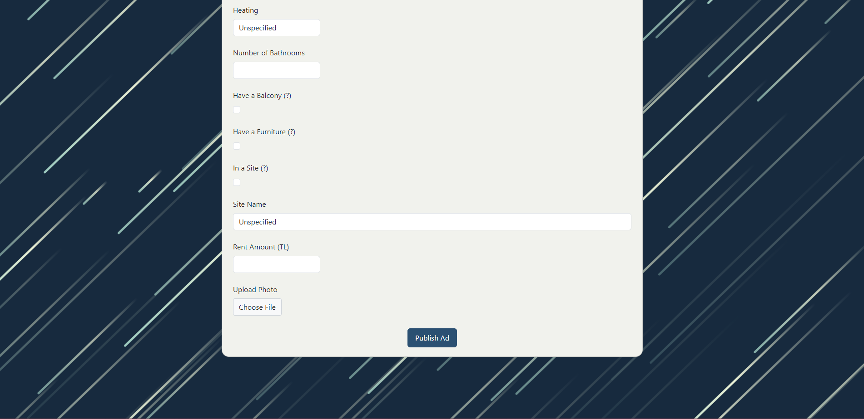

Figure 39: Landlord Publish Ad interface (Cont’d)

Landlord can finally upload the photos of the house in the ad and publish it.

#### 3.5.5.27 Rental Notifications:

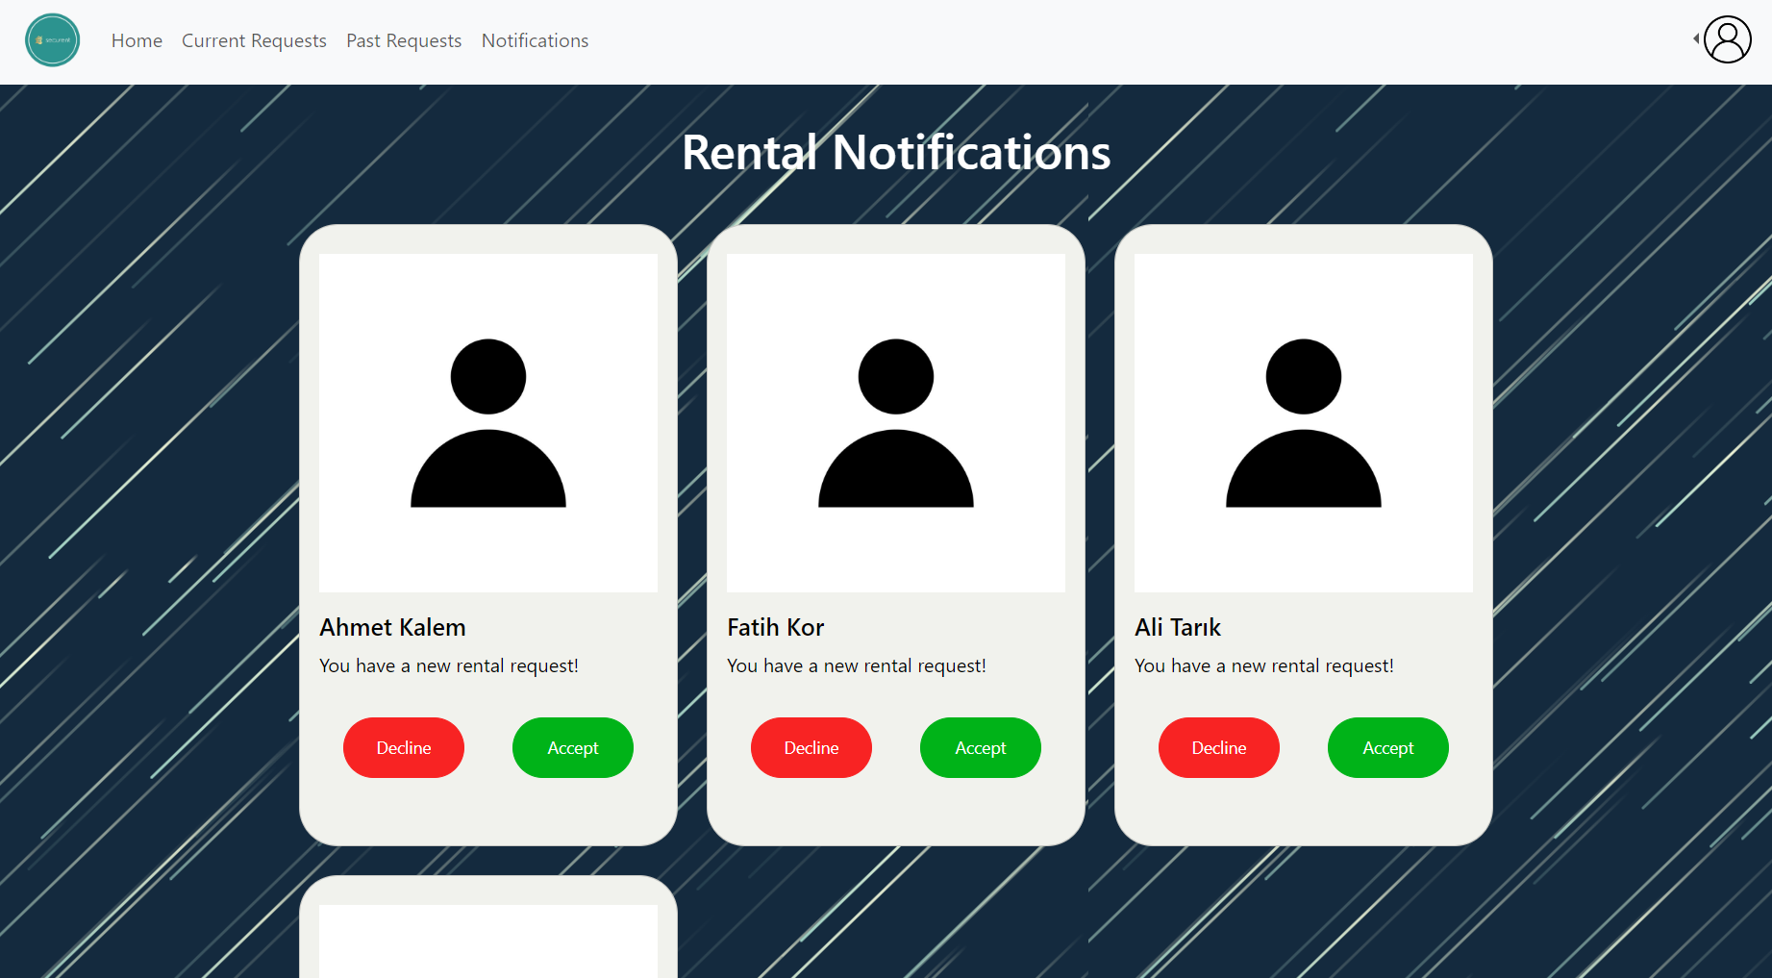

Figure 40: Rental Notifications interface

When a request for a tour occurs, the landlord takes a rental notification, and these notifications are displayed on this page. They can either decline or approve the request. Also, the landlord can go to the profile page of the tenant by clicking the notification card.

#### 3.5.5.28 Rate Real Estate Agent for Landlord:

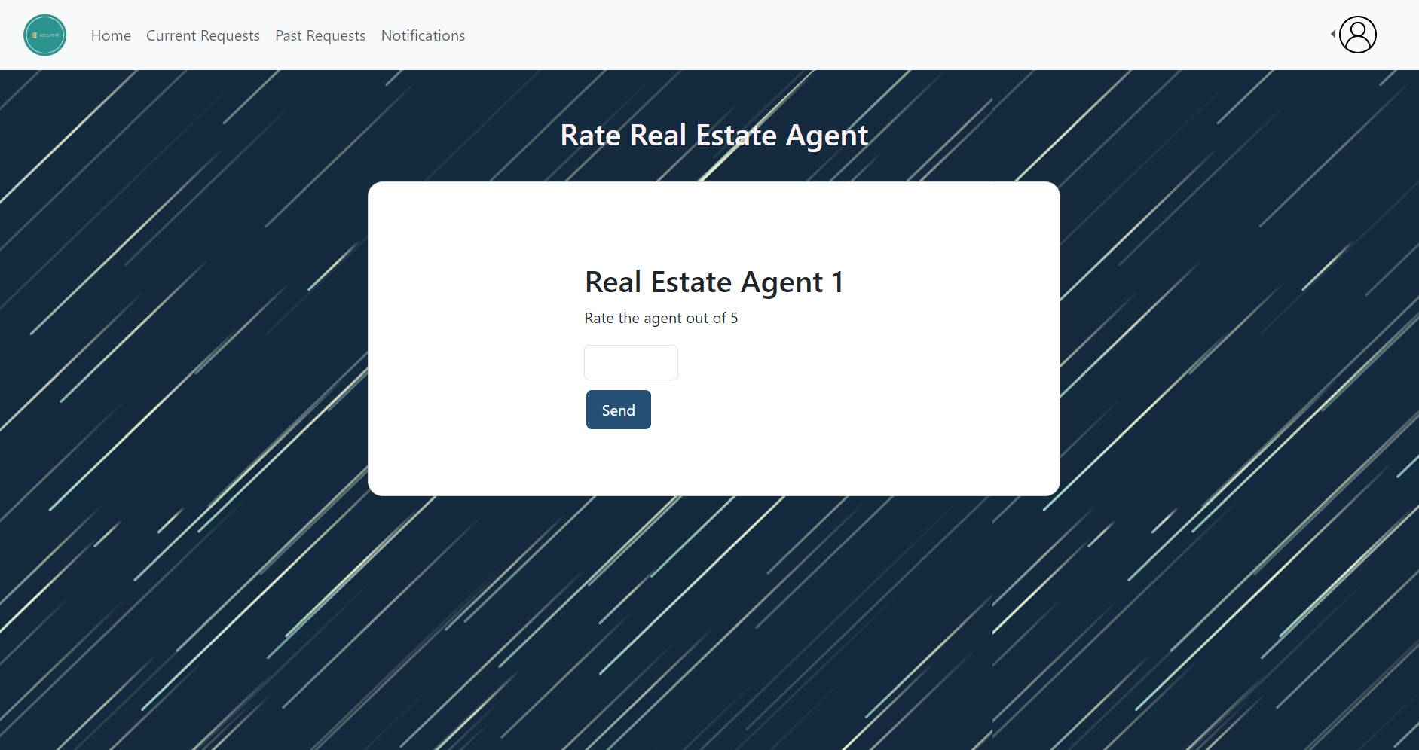

Figure 41: Rate Real Estate Agent for Landlord interface

After the touring process ends, landlords need to rate the real estate agent. Rating will be done out of 5.

#### 3.5.5.29 Current Rental Request:

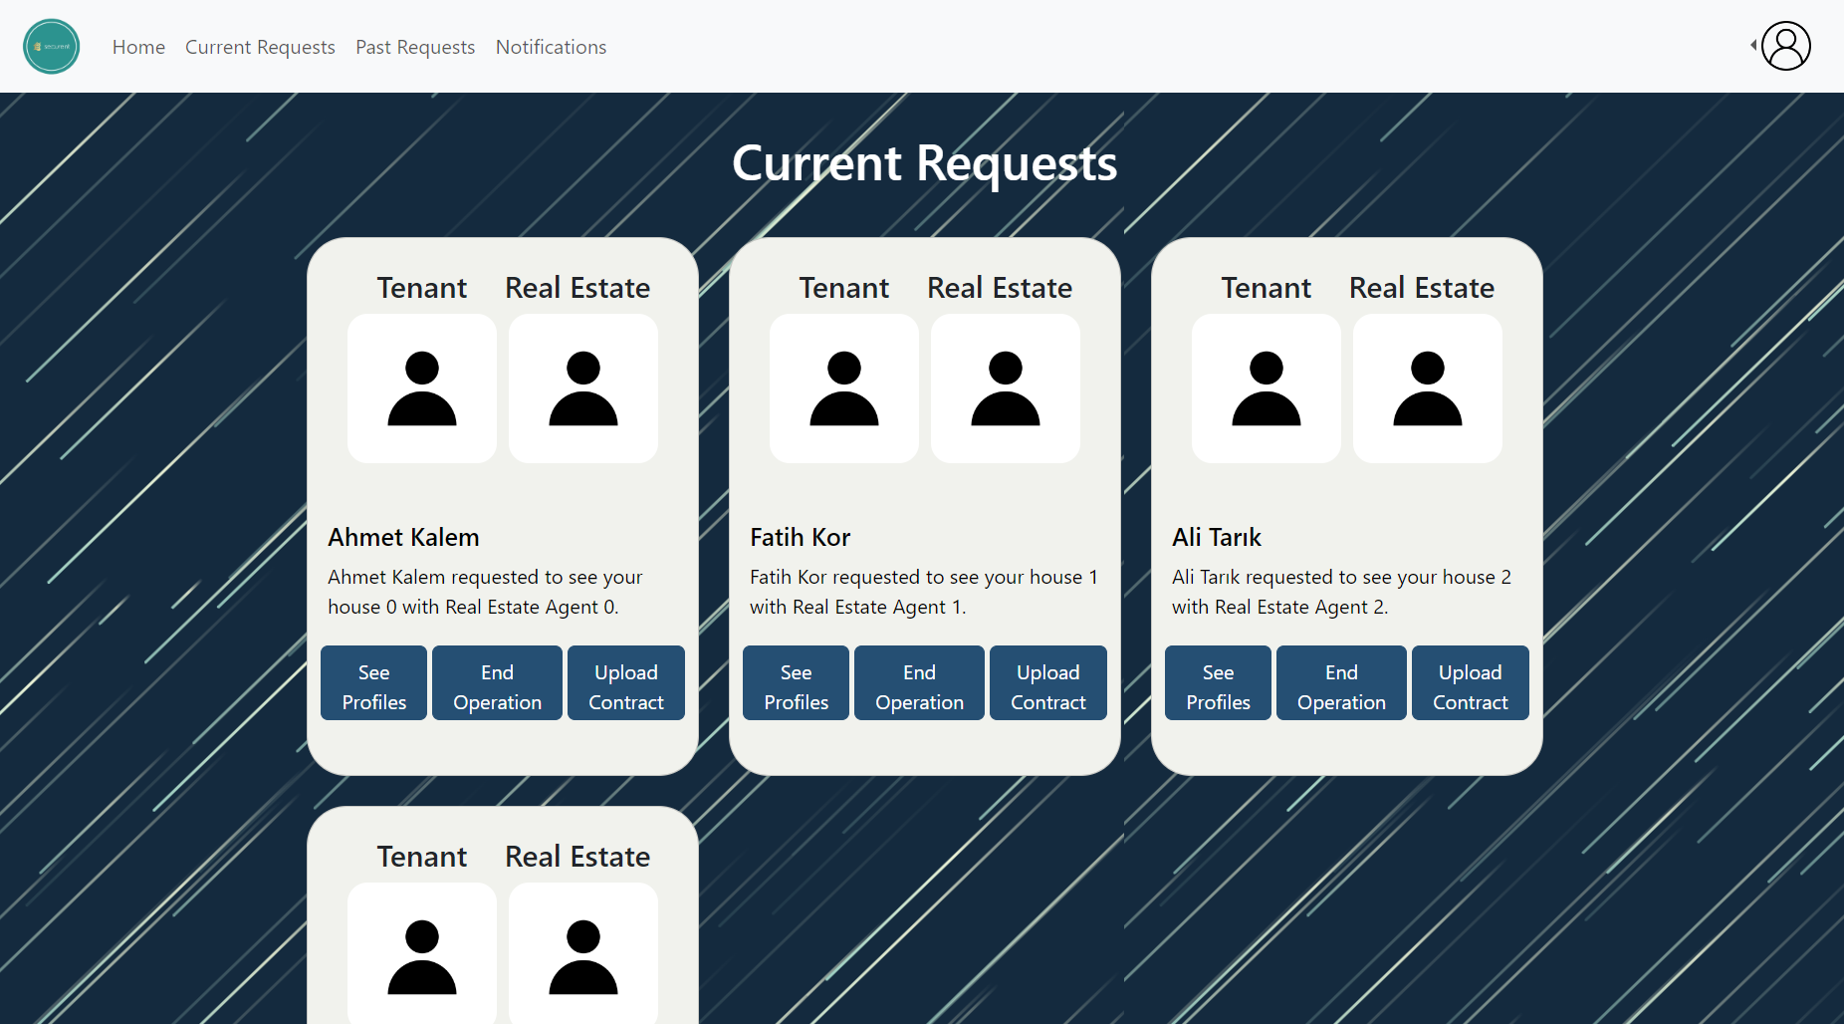

Figure 42: Current Rental Request interface

When the landlord accepts the rental request, it moves to the ”Current Requests” page. Landlord can see the tenant’s and the real estate agent’s profile photos. Also, when the see profiles button is clicked, the user will be directed to a page in which tenant’s and real estate agent’s profiles are displayed. The user can end operation by clicking the end operation button. Landlords can upload the contract if they agree to rent the house.

#### 3.5.5.30 Past Rental Request:

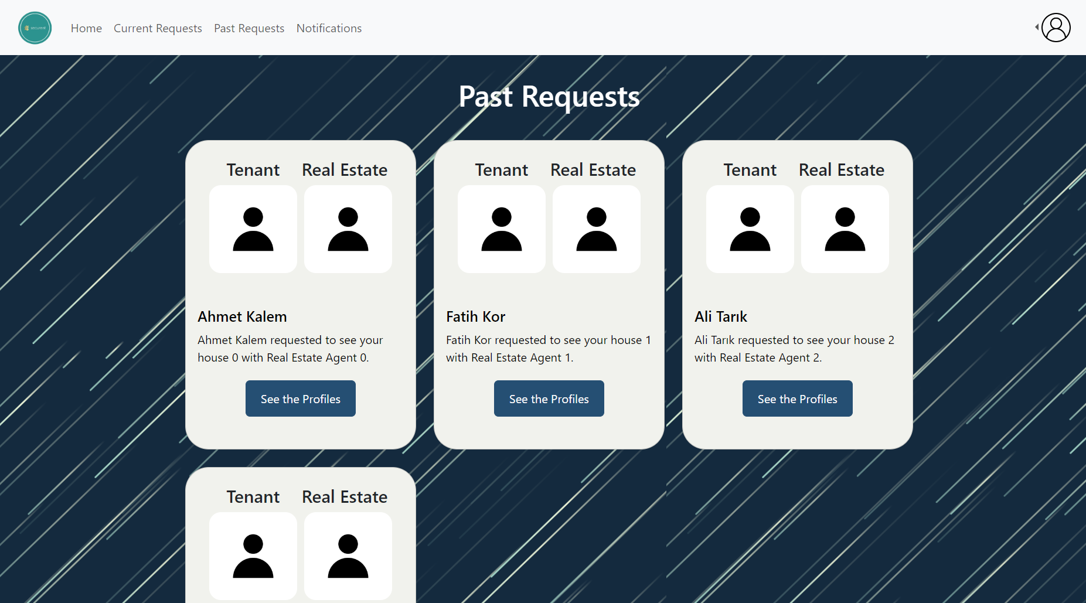

Figure 43: Past Rental Request interface

When the process is ended, the past rental tour operations are displayed in this page. Tenant’s and real estate agent’s profiles can be displayed by clicking the button.

#### 3.5.5.31 Landlord Profile:

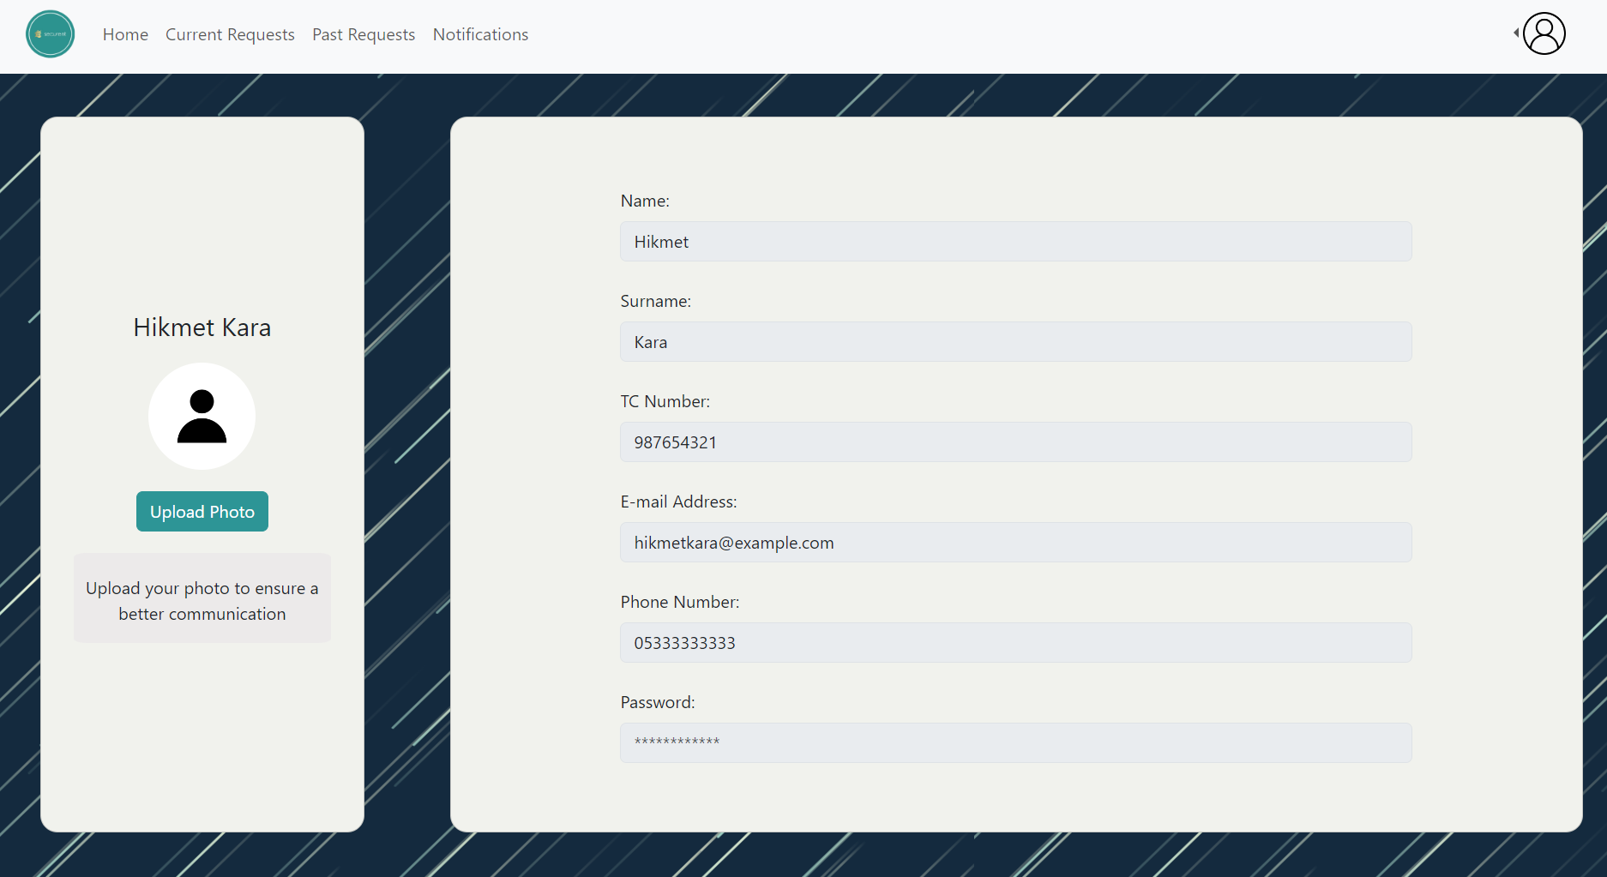

Figure 44: Landlord Profile

Information of the landlord such as name, surname, TC number, e-mail address, phone number is displayed on this page. The password is censored. Users can also see her/his profile picture and edit the profile picture. If the user does not upload any profile picture, the default one is shown.

#### **3.5.5.32** Real Estate Agent Home Page:

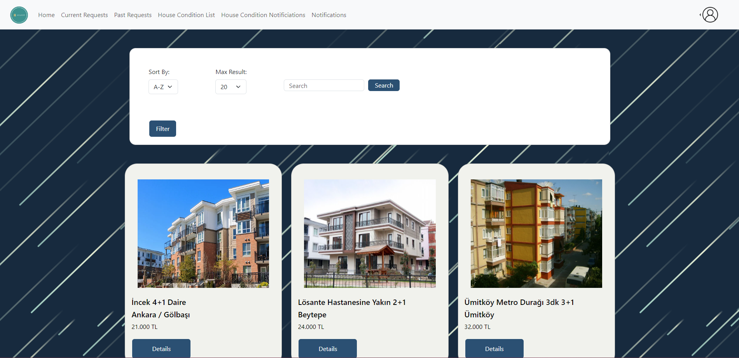

Figure 45: Real Estate Agent Home Page

This is the home page for a real estate agent. They can view the houses based on their location, and they can filter the ads they see or they can search for one. Their homepage navigation bar includes: Home, Current Requests, Past Requests, House Condition List, House Condition Notifications, and Notifications.

#### 3.5.5.33 Real Estate Agent Requests:

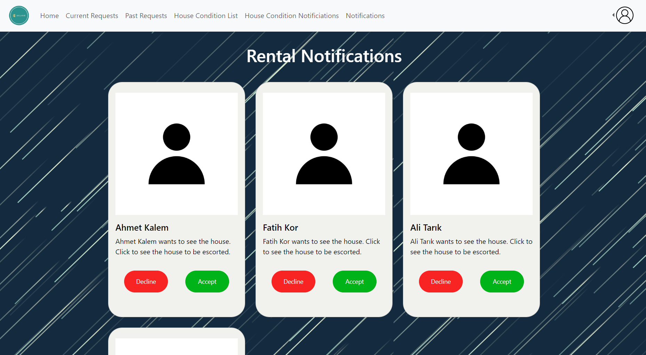

Figure 46: Real Estate Agent Requests interface

Similar to the landlord, real estate agents get rental notifications to make a tour for the tenant. They can either decline or accept the request. When the notification card is clicked they can display the house to be escorted.

#### 3.5.5.34 Real Estate Agent Current Requests:

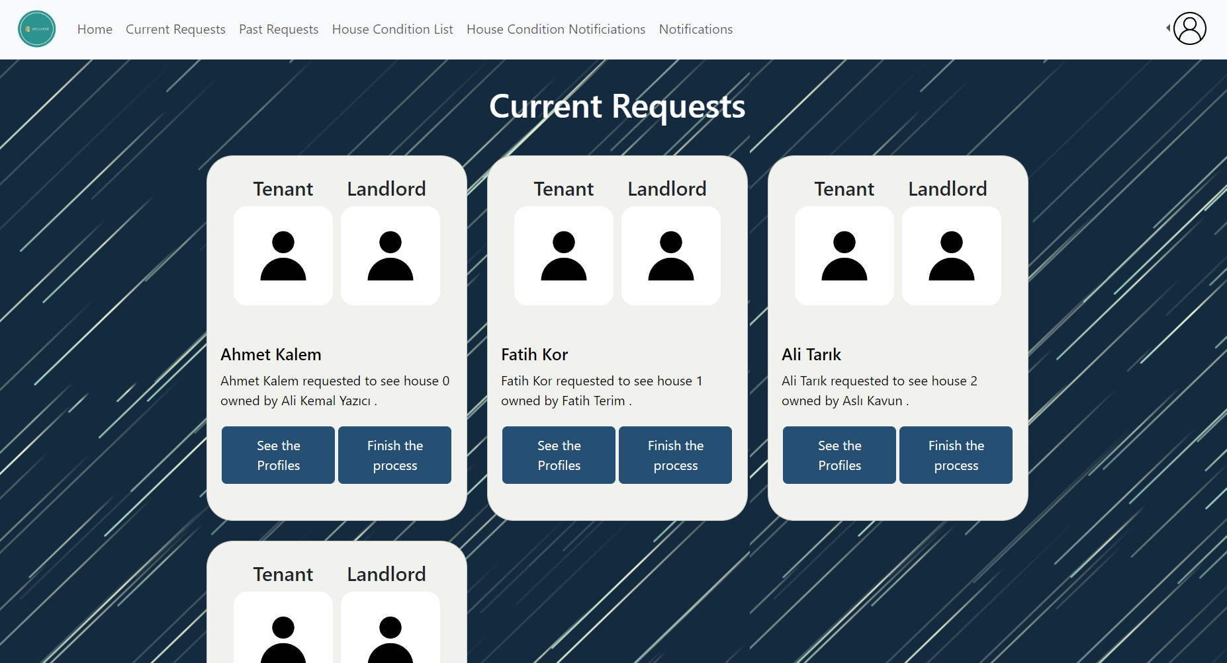

Figure 47: Real Estate Agent Current Requests interface

When the real estate agent accepts the rental request, it moves to the ”Current Requests” page. Real estate agents can see the tenant’s and the landlord’s profile photos. Also, when the see profiles button is clicked, the user will be directed to a page in which tenant’s and landlord’s profiles are displayed. When the finish process button is clicked, the request will be moved to the “Past Requests” page. After the process is finished, the tenant and landlord can rate the real estate agent.

#### 3.5.5.35 Real Estate Agent Past Requests:

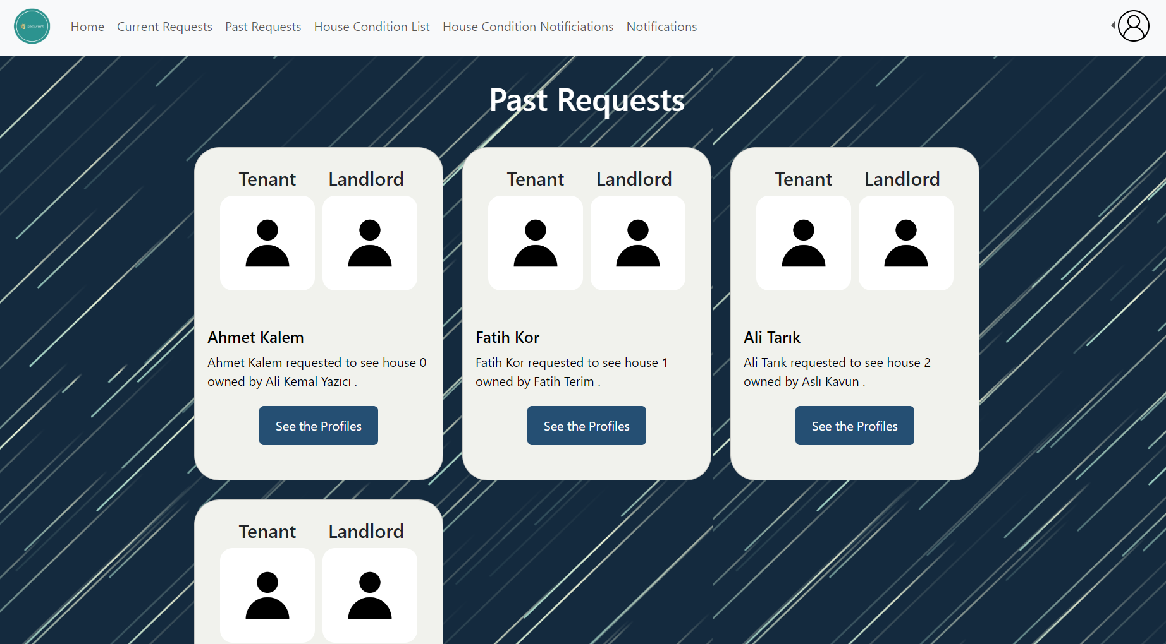

Figure 48: Real Estate Agent Past Requests interface

When the process is ended, the past rental tour operations are displayed in this page. Tenant’s and landlord’s profiles can be displayed by clicking the button.

#### 3.5.5.36 Real Estate Agent Profile:

# 

Figure 49: Real Estate Agent Profile

Information of the real estate agent such as name, surname, TC number, e-mail address, phone number is displayed on this page. The password is censored. Users can also see her/his profile picture and edit the profile picture. If the user does not upload any profile picture, the default one is shown. In addition to other actors, location and ranking information of the real estate agent is displayed on this page.

#### 3.5.5.37 Real Estate Agent House Condition Check Notification:

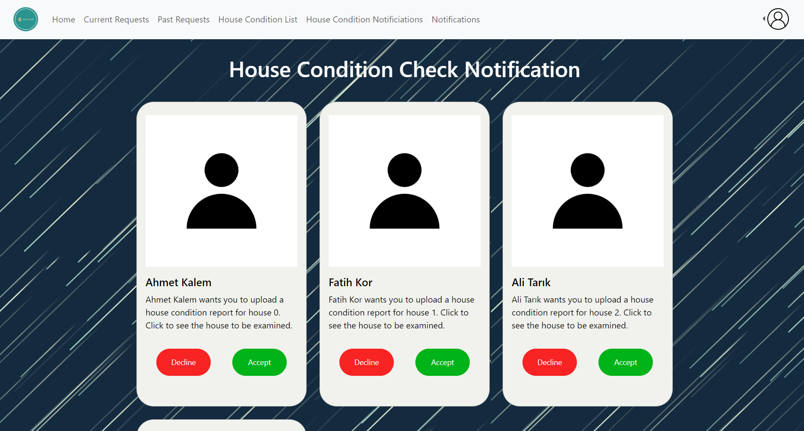

Figure 50: Real Estate Agent House Condition Check Notification interface

When a real estate agent gets a house condition check request, it is shown on this page. The user can either accept or decline it. When the card is clicked, the house to be examined will be displayed.

#### 3.5.5.38 Real Estate Agent House Condition Check Notification:

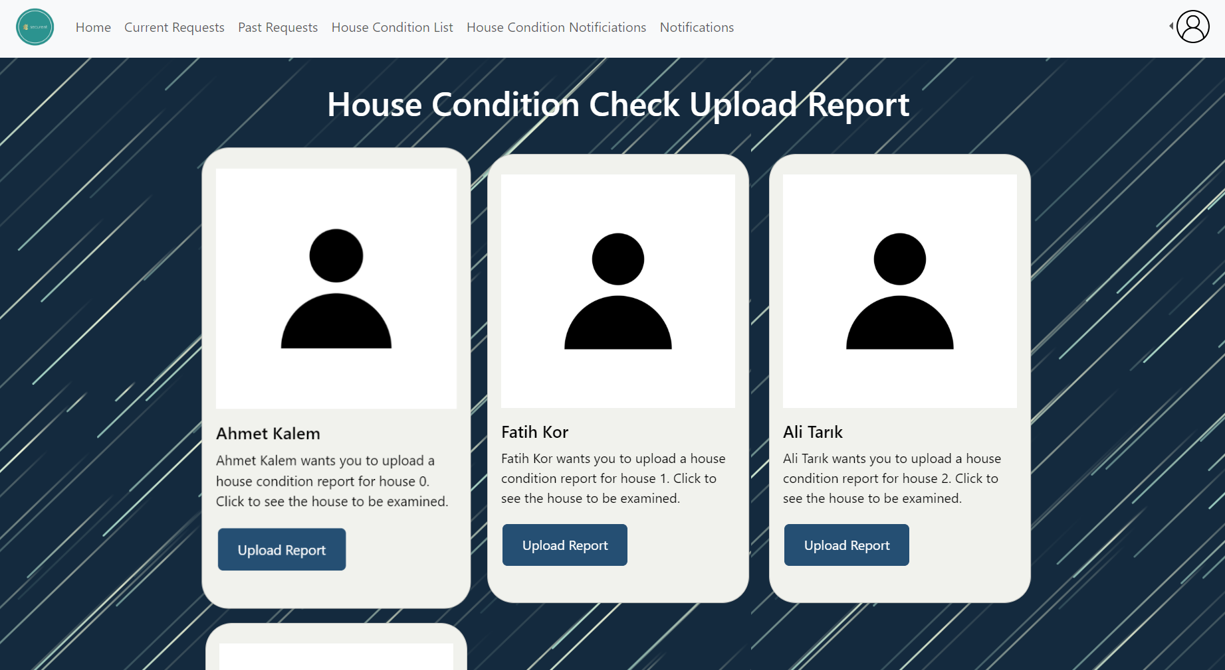

Figure 51: Real Estate Agent House Condition Check Notification interface

On this page, real estate agent’s accepted house condition check requests are displayed. The user can upload the condition check report by clicking the button.When the card is clicked, the house to be examined will be displayed.

#### 3.5.5.39 Landlord Profile From Another POV:

# 

Figure 52: Landlord Profile From Another POV

When a landlord profile is displayed from another user, it will be seen as the figure above.

#### 3.5.5.40 Tenant Profile From Another POV:

# 

Figure 53: Tenant Profile From Another POV

When a tenant profile is displayed from another user, it will be seen as the figure above.

#### 3.5.5.41 Real Estate Agent Profile From Another POV:

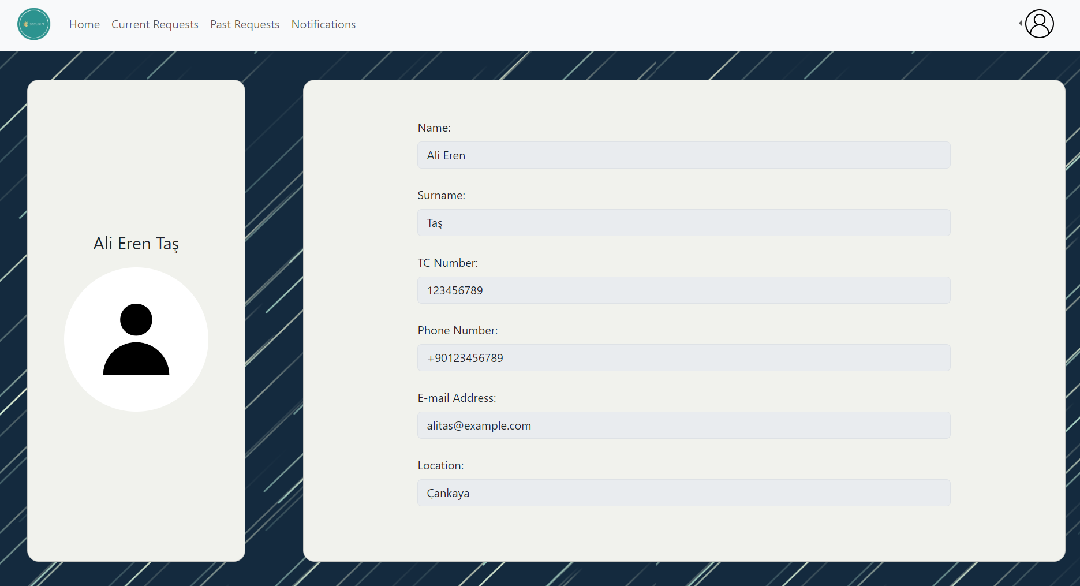

Figure 54: Real Estate Agent Profile From Another POV

When a real estate agent profile is displayed from another user, it will be seen as the figure above.

#### 3.5.5.42 Tenant and Landlord View from Another POV:

# 

Figure 55: Tenant and Landlord View From Another POV

When a real estate agent clicks to see the profiles button on the “Current Requests” page and “Past Requests” page, this page will be displayed.

#### 3.5.5.43 Tenant and Real Estate Agent View from Another POV:

# 

Figure 56: Tenant and Real Estate Agent View From Another POV

When a landlord clicks to see the profiles button on the “Current Requests” page and “Past Requests” page, this page will be displayed.

#### 

#### 3.5.5.44 Create State Official Page:

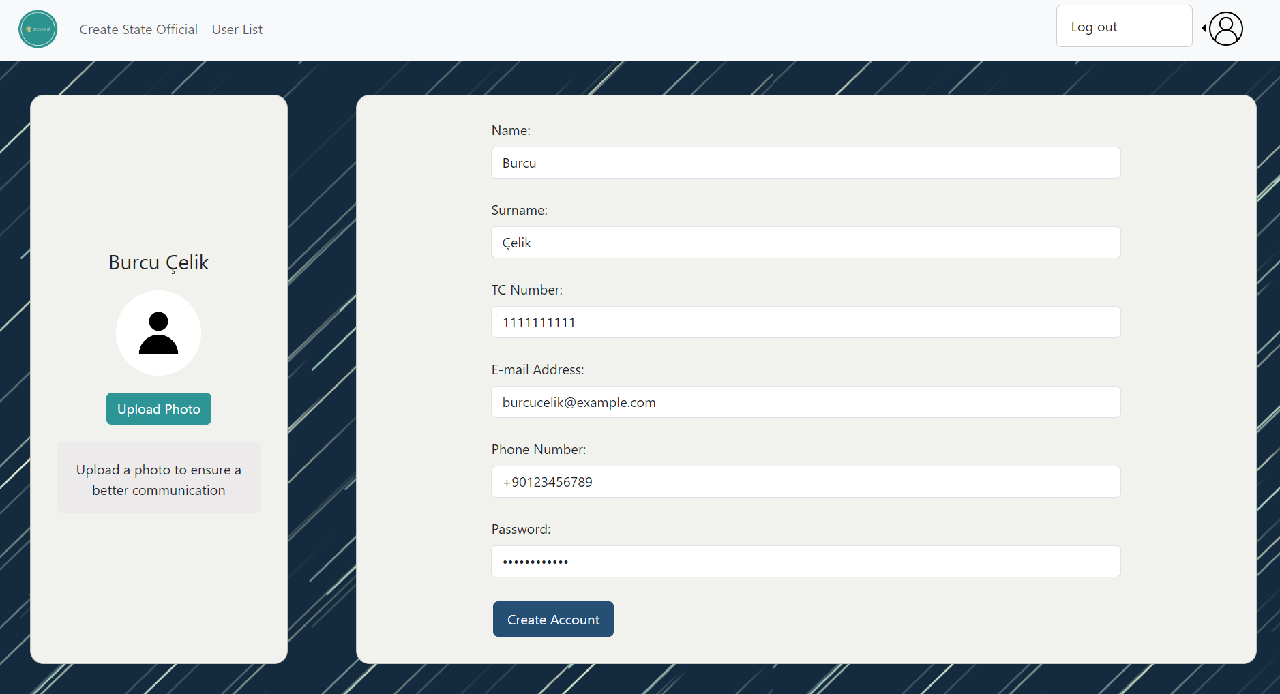

Figure 57: Admin’s create state official page

State official accounts can only be created by admin. Admin fills the form to create state official accounts.

#### 3.5.5.45 List Users Page:

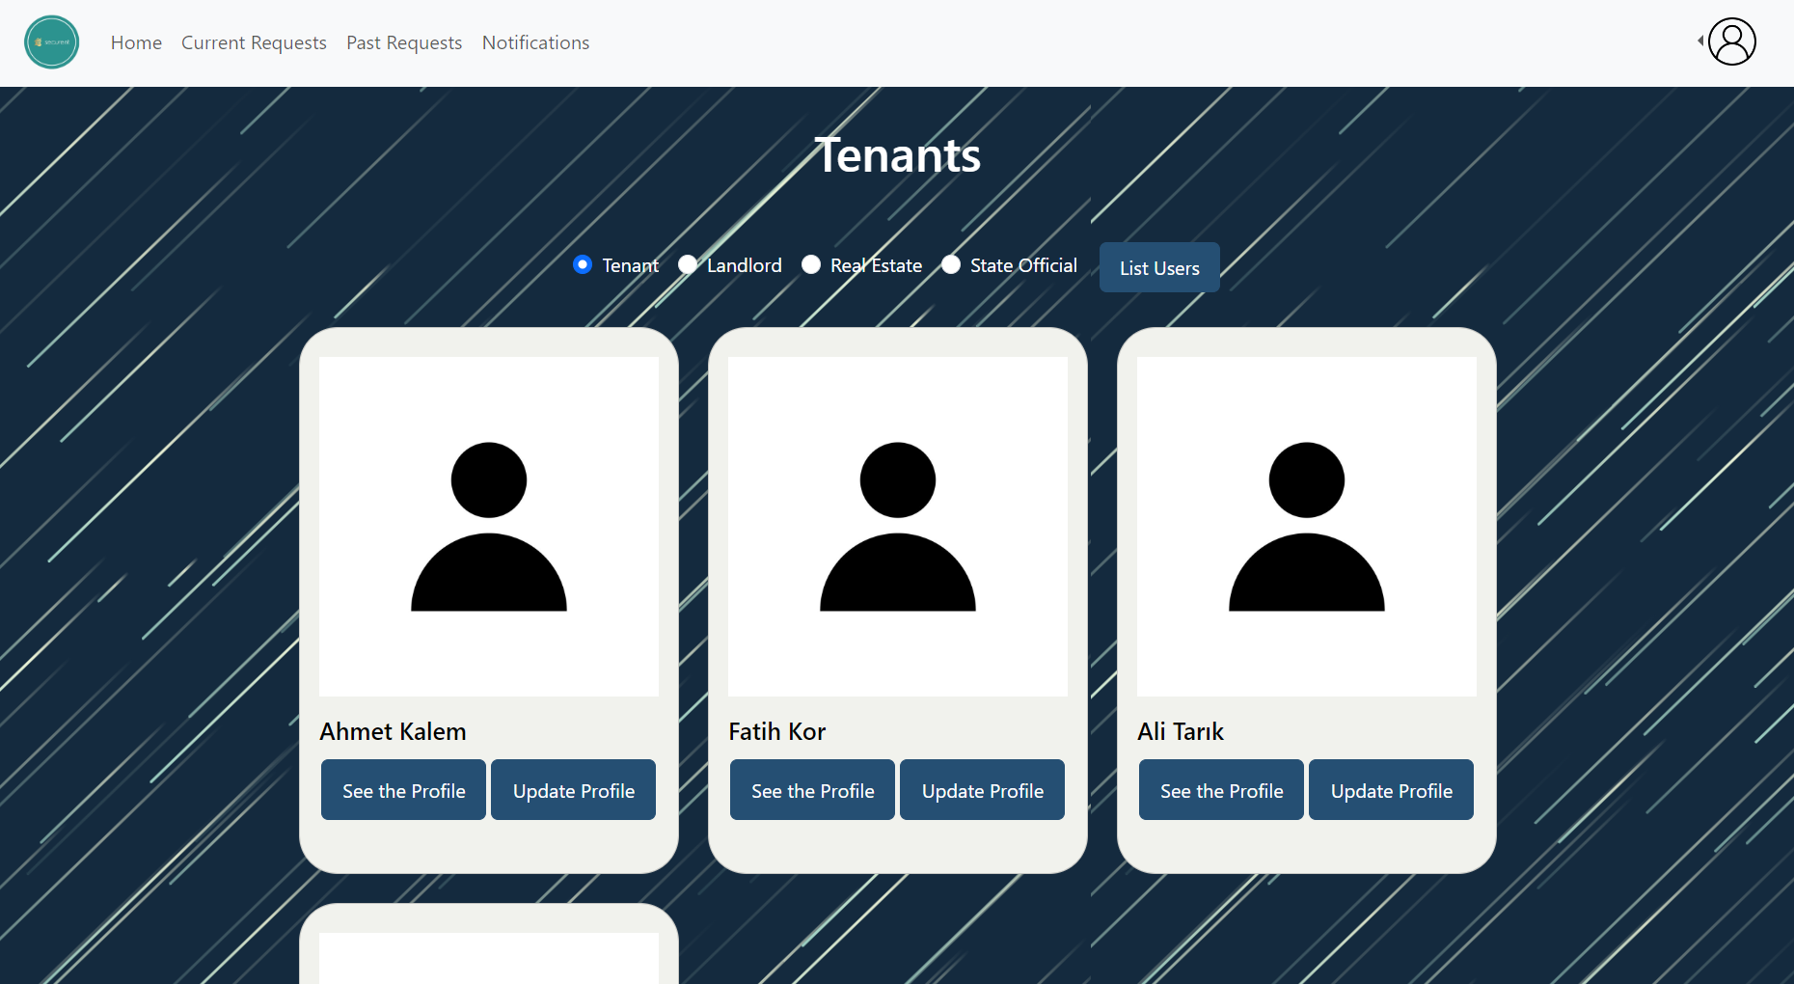

Figure 58: Admin’s list users official page

Admin can display the user list by choosing the user type. When the admin clicks the see the profile button, the user profile will be shown. Admin can also update the profile information of the users.

#### 3.5.5.46 Update Profile:

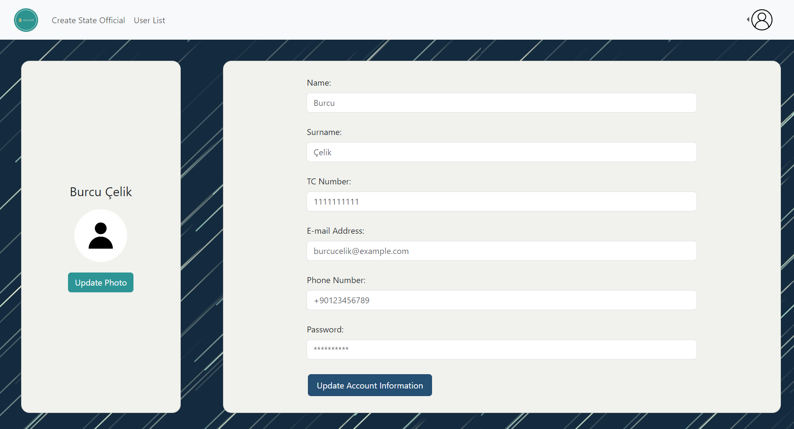

Figure 59: Admin’s update profile page

User’s profile information can be updated in this page by filling the form above. Also, the profile photo can be changed here.

# **4.** **Other Analysis Elements**

## 4.1 Consideration of Various Factors in Engineering Design

### 4.1.1 Constraints

We considered the following constraints while regarding the functional and nonfunctional requirements of SecuRent.

**Legal Considerations:** Legal considerations are crucial for the success and compliance of the SecuRent project, given its involvement in the house rental process and the handling of sensitive data. We need to protect the user’s data and get consent from them regarding the collection, processing, and storage of their personal information. We should also comply with the Rental Regulations of the government.

**Usability:** We should provide a simple user interface that is not complicated. We need to prioritize a clean and intuitive user interface. We should ensure that common tasks are easily achievable and that users can quickly understand and navigate through the application. We are aiming to meet a user and his/her goal in at most 10 clicks. Hence, we are developing our application to satisfy intuitiveness and simpleness.

**Maintainability:** We need to design the application with a modular structure, separating different components or modules. We should also provide comprehensive documentation for the application's architecture, codebase, and data structures, and database so that our project can be maintained easily (as mentioned in the NFR section in detail as well).

**Accessibility:** Accessibility is a critical aspect of the SecuRent project, ensuring that the application is usable by individuals with diverse abilities, including those with disabilities. Considerations for accessibility in the SecuRent application are essential to provide an inclusive user experience. Our project has potential users from all regions of Turkey. Moreover, people from different ethnic backgrounds, gender, and age will use the SecuRent, without facing any discrimination.

**Constructability**: Constructability in the context of the SecuRent refers to the ease with which the application can be built and implemented successfully. A focus on constructability ensures that the development process is efficient, cost-effective, and aligns with the project's goals. We need to provide incremental development, breaking the project into manageable phases or iterations. This allows for continuous testing, validation, and adjustment of features as the development progresses. Last but not least, our unit tests will help us to build an efficient and a constructible application.

In the following table, the effect levels range from 0 to 10 (0 having no effect, 1 having the least and 10 having the greatest effect).

|  | Effect level | Effect |
| --- | --- | --- |
| Public health | 0 | Public Health does not affect any part of the solutions since the solutions are not intended for any problems in public health. |
| Public safety | 10 | Public Safety has a great effect because one of the primary aims of SecuRent is to ensure the safety of rental ads, rent amounts, deposits, and landlord-tenant contracts for houses. |
| Public welfare | 10 | Public Welfare has a great effect on the solutions since the aim of the project is to provide a service to the tenants, landlords and government, which is for public welfare specifically. |
| Global factors | 4 | Global Factors do not have a big impact on the solutions because the problems that are to be resolved or reduced by Securent are not global problems. Yet, it is for public advantage, so it can be scaled as an effect level of 4. |
| Cultural factors | 0 | Cultural Factors have no effect on the way the solutions are designed because SecuRent does not aim to provide any measures/advantages on the cultural factors: it will function for the benefit of the public in general. |
| Social factors | 6 | Social Factors have an impact on the solutions, but they are second to public safety and public welfare. The solutions for SecuRent are affected by the social factors in the way that it aims to increase the trust and work ethics between landlords, tenants and real estate agents. |
| Environmental factors | 0 | Environmental Factors have no effect on the way the solutions for SecuRent are shaped. SecuRent has no concerns (or will not deal with the issues) of environmental problems. |
| Economic factors | 6 | Economic factors have some impact on the solutions design but just like social factors, it comes after public safety and public welfare. Economic factors sparked the idea that the government should hold the deposits of rental houses for them to make a profit and add up extra income. |

### 4.1.2 Standards

* UML 2.5.1 is used through the draw.io platform to model the high level architecture of the system.
* Architectural Patterns: Module style is used to model the class diagram architecture. Specifically following styles are used:
  + Decomposition Style: Modules are separated into submodules to cover functionalities within the parent module.
  + Uses Style: Different modules connect to each other with the user relationship as particular modules require the functionality of other modules.
  + Layered Style: Different layers allow different functionalities to be separate. For instance UI and core module are distinct layers and interact with each other through an intermediary API layer.
* Software Development Standards: The software development of the SecuRent should be applied by following the reports and aiming for the actual final product. The standards of the development phase should be complied which involve the language and technology choices and predefined development processes.
* Usability Standards: The User Interface (UI) and User Experience (UX) of the SecuRent should be considered so that it follows the usability standards that are user friendly, intuitive, and easy to navigate in the system.
* Quality Assurance Standards: SecuRent should comply with the quality assurance standards that are satisfying the requirements of the project. Also the quality of the final product should be fine enough to be used as a rental regulatory application.

## 4.2 Risks and Alternatives

Our project has numerous possible risks. We carefully evaluated and considered alternatives. If the risks we consider occur, we will implement the following alternatives.

**1. Potential Risk: Government Non-Support**

There is a risk that the government may not provide the anticipated support for the project. This lack of support could be due to changes in political priorities, budget constraints, or a shift in policy that affects the project's alignment with governmental objectives or they simply may not like our project. Specifically, we contacted the Ministry of Environment, Urbanisation and Climate Change to introduce our project. We have made phone calls several times, and met with the response of “We will consider that, thank you for your efforts. We cannot give a definite answer to support your project right now”. Hence, we kept calling the ministry (specifically IT department of it) every 2 weeks to remind ourselves and ask about their decision to support our project. However, they again did not give an answer or sometimes they simply closed the phone while we were waiting to speak with them. Hence, we could not learn if the ministry is in favor of our project.

**Alternative solution: Align with Government Priorities**

We will ensure that the project aligns with the current government priorities and policies. Regularly assess and, if necessary, adapt the project to meet evolving governmental objectives, demonstrating its relevance and contribution to broader societal goals. Furthermore, we are planning to have a face to face rendezvous with the IT department under the Ministry of Environment, Urbanisation and Climate Change to discuss our application and leave a better impression with our enthusiasm and dedication to achieve our goals.

**2. Potential Risk: Data Security and Privacy Concern**

Given that SecuRent involves handling sensitive information related to house rentals, there is a potential risk of data security and privacy breaches. Unauthorized access to or disclosure of personal and financial data could harm the reputation of the application, erode user trust, and lead to legal consequences.

**Alternative Solution: Robust Data Security Measures and Compliance Framework**

In case such a privacy concern occurs, we will stay compliant with relevant data protection laws and regulations in the jurisdictions where SecuRent operates. In addition, user education will be considered as well. Training users (both tenants and landlords) about best practices for securing their accounts and sensitive information will be carried out. We will also promote strong password policies during sign up and provide guidance on recognizing and reporting potential security threats.

**3. Potential Risk: Adoption Resistance and User Acceptance**

There is a risk that users, both tenants, and landlords, may resist adopting the SecuRent application, leading to low user acceptance. Resistance can stem from factors such as unfamiliarity with the technology, concerns about privacy, or a reluctance to change established rental processes.

**Alternative Solution: Comprehensive Stakeholder Involvement**

We will involve key stakeholders, including potential users, in the development process. We will gather input from tenants, landlords, and government officials to ensure the application meets their needs and addresses concerns.

## 4.3 Project Plan

| **WP#** | **Work package title** | **Leader** | **Members involved** |
| --- | --- | --- | --- |
| WP 1 | Project Specification | Arda | Yunus, Kaan, Cengizhan, Yusuf |
| WP 2 | Analysis and Requirements Report | Arda | Yunus, Kaan, Cengizhan, Yusuf |
| WP 3 | Logbook | Yunus | Arda |
| WP 4 | Presentation and Demos | Kaan | Arda, Yunus, Cengizhan, Yusuf |
| WP 5 | Detailed Design Report Guideline | Yunus | Arda, Kaan, Cengizhan, Yusuf |
| WP 6 | Presentation Layer | Kaan | Arda, Yunus |
| WP 7 | Business Logic Layer | Cengizhan | Arda, Yusuf |
| WP 8 | Data Access Layer | Yusuf | Arda, Cengizhan |
| WP 9 | Deployment | Cengizhan | Arda, Yusuf |
| WP 10 | Web Service Management | Cengizhan | Yunus, Kaan |
| WP 11 | Design | Yusuf | Arda, Cengizhan, Yunus, Kaan |
| WP 12 | Project Management | Arda | Yunus, Kaan, Cengizhan, Yusuf |

Table 1: List of work packages

| **WP 1:** *Project Specification* | | | |
| --- | --- | --- | --- |
| **Start date:** *10 November 2023* **End date:** *17 November 2023* | | | |
| **Leader:** | *Arda* | **Members involved:** | *Yunus, Kaan, Cengizhan, Yusuf* |
| **Objectives:**  *Write the specifications of the project* | | | |
| **Tasks:**  ***Task 1.1*** ***Introduction: Introduce the project.***  ***Task 1.2*** ***Design Requirements: Provide a high level architecture. Moreover, give the design requirements of the project.***  ***Task 1.3*** ***Feasibility Discussions: Make a market analysis and discuss the feasibility of the project.***  ***Task 1.4*** ***References: Share the sources used.*** | | | |
| **Deliverables**  ***D1.1:*** *Project Specification Document* | | | |
| **WP 2:** *Analysis and Requirements Report* | | | |
| **Start date:** *1 December 2023* **End date:** *8 December 2023* | | | |
| **Leader:** | *Arda* | **Members involved:** | *Yunus, Kaan, Cengizhan, Yusuf* |
| **Objectives:** *Write the detailed analysis and requirements of the project* | | | |
| **Tasks:**  ***Task 2.1*** *Introduction: Introduce the project.*  ***Task 2.2*** ***Current System (if any)*:** *Share the details of the current system and compare it to similar projects/systems (if any).*  ***Task 2.3 Proposed System****: Share the technical details of the proposed system. Give functional and non-functional requirements. Provide class and use case diagrams. Share dynamic models.*  ***Task 2.4 Other Analysis Elements****: Share the constraints, risks, and work packages.*  ***Task 2.5. Glossary****: Share the domain specific terms.*  ***Task 2.6. References****: Share the sources used.* | | | |
| **Deliverables**  ***D2.1:*** *Analysis and Requirements Report* | | | |
| **WP 3:** *Logbook* | | | |
| **Start date:** *10 January 2024* **End date:** *5 May 2024* | | | |
| **Leader:** | *Yunus* | **Members involved:** | *Arda, Yusuf* |
| **Objectives:** *Provide a logbook of the project. Share all the important work done.* | | | |
| **Tasks:**  ***Task 3.1*** ***Chronological Order*:** *Share the work done in the chronological order* | | | |
| **Deliverables**  ***D3.1:*** *Logbook* | | | |
| **WP 4:** *Presentation and Demos* | | | |
| **Start date:** *10 December 2023* **End date:** *15 December 2023* | | | |
| **Leader:** | *Kaan* | **Members involved:** | *Arda, Yunus, Cengizhan, Yusuf* |
| **Objectives:** *Prepare and present the project in the demo* | | | |
| **Tasks:**  ***Task 4.1*** ***Preparation****: Prepare slides for the demo.*  ***Task 4.2*** ***Presentation*:** *Present the project in the demo.* | | | |
| **Deliverables**  ***D4.1:*** *Presentation and Demo* | | | |
| **WP 5:** *Detailed Design Report Guideline* | | | |
| **Start date:** *2 March 2024* **End date:** *15 March 2024* | | | |
| **Leader:** | *Yunus* | **Members involved:** | *Arda, Kaan, Cengizhan, Yusuf* |
| **Objectives:** *Write a detailed design report guideline for the CS 492 course* | | | |
| **Tasks:**  ***Task 5.1*** ***Template****: Follow the report template that will be shared in the spring semester. Add more sub tasks when the details are shared.* | | | |
| **Deliverables**  ***D5.1:*** *Detailed Design Report* | | | |
| **WP 6:**Presentation Layer | | | |
| **Start date:** *17 November 2023* **End date:** *30 December 2023* | | | |
| **Leader:** | *Kaan* | **Members involved:** | *Arda, Yunus* |
| **Objectives:** *Cover the presentation layer of SecuRent application, which corresponds to the UI layer. Use React.js and Bootstrap libraries.* | | | |
| **Tasks:**  ***Task 6.1*** ***Tenant****: Complete the required pages for the tenant perspective of the system.*  ***Task 6.2 Landlord****: Complete the required pages for the landlord perspective of the system.*  ***Task 6.3 Real Estate Agent****: Complete the required pages for the real estate agent perspective of the system.*  ***Task 6.4 Government****: Complete the required pages for the government perspective of the system.*  ***Task 6.5*** ***Login****: Complete the login page of the system. Email and password fields are required for the login page.*  ***Task 6.6*** ***Sign Up****: Complete the sign up page of the system. User credentials including TCK number are required.*  ***Task 6.7 Unit Tests****: Write unit tests for the source code written for the above pages. Use Karma for configuration and Jasmine for writing the test cases. Use BDD syntax.* | | | |
| **Deliverables**  ***D6.1:*** ***Tenant pages***  ***D6.2:*** ***Landlord pages***  ***D6.3:*** ***Real Estate Agent pages***  ***D6.4:*** ***Government pages***  ***D6.5:*** ***Login page***  ***D6.6:*** ***Sign Up******page***  ***D6.7:*** ***Unit Tests*** | | | |
| **WP 7:** *Business Logic Layer* | | | |
| **Start date:** *17 November 2023* **End date:** *30 January 2024* | | | |
| **Leader:** | Cengizhan | **Members involved:** | *Arda, Yusuf* |
| **Objectives:** *Implement the business logic layer of SecuRent application, which corresponds to the functionality to be covered in the back end side.* | | | |
| **Tasks:**  ***Task 7.1*** ***Tenant****: Complete the functionality required for the tenant perspective of the system.*  ***Task 7.2 Landlord****: Complete the functionality required for the landlord perspective of the system.*  ***Task 7.3 Real Estate Agent****: Complete the functionality required for the real estate agent perspective of the system.*  ***Task 7.4*** ***Government****: Complete the functionality required for the government perspective of the system.*  ***Task 7.5*** ***NFR****: Refer to the non-functional requirements required for the system to operate smoothly. Comply with the non functional requirements and satisfy them.*  ***Task 7.6 Unit Tests****: Write unit tests for the source code written for the above functionalities. Use JUnit for writing the test cases, and use the test annotation of Spring.* | | | |
| **Deliverables**  ***D7.1:*** ***Tenant business logic***  ***D7.2:*** ***Landlord business logic***  ***D7.3:*** ***Real Estate Agent business logic***  ***D7.4:*** ***Government business logic***  ***D7.5:*** ***Non-functional requirements***  ***D7.6:*** ***Unit Tests*** | | | |
| **WP 8:** *Data Access Layer* | | | |
| **Start date:** *1 January 2024* **End date:** *1 March 2024* | | | |
| **Leader:** | *Yusuf* | **Members involved:** | *Arda, Cengizhan* |
| **Objectives:** *Integrate the data access layer to the system. Next, set up the communication between the database and the business layer.* | | | |
| **Tasks:**  ***Task 8.1*** ***Integration****: Integrate/configure the database to the system*  ***Task 8.2*** ***Communication*:** *Set up the communication/connection between the data access layer and the business logic layer.*  ***Task 8.3*** ***Create Mocks*:** *Create mock data to test the backend connection of the system* | | | |
| **Deliverables**  ***D8.1:*** *Functioning database* | | | |
| **WP 9:** *Deployment* | | | |
| **Start date:** *1 March 2024* **End date:** *30 March 2024* | | | |
| **Leader:** | *Cengizhan* | **Members involved:** | *Arda, Yusuf* |
| **Objectives:** *Integrate the AWS EC2 into the system. Host the application on EC2.* | | | |
| **Tasks:**  ***Task 9.1*** ***Hosting****: Host the application on the EC2 servers.* | | | |
| **Deliverables**  ***D9.1:*** *Hosted Application on EC2* | | | |
| **WP 10:** *Web Service Management* | | | |
| **Start date:** *1 April 2024* **End date:** *15 May 2024* | | | |
| **Leader:** | *Cengizhan* | **Members involved:** | *Yunus, Kaan* |
| **Objectives:** *Manage the deployed application on the website.* | | | |
| **Tasks:**  ***Task 10.1*** ***Maintenance:*** *Perform maintenance on the deployed application.* | | | |
| **Deliverables**  ***D10.1:*** *Maintenance of Deployed Application* | | | |
| **WP 11:** *Design* | | | |
| **Start date:** *1 April 2024* **End date:** *15 April 2024* | | | |
| **Leader:** | *Yusuf* | **Members involved:** | *Arda, Cengizhan, Yunus, Kaan* |
| **Objectives:** *Design of the web application, and logo of the project.* | | | |
| **Tasks:**  ***Task 11.1*** ***Decision Process:*** *Investigate on possible logo designs and colors.*  ***Task 11.1*** ***Design:*** *Implement the design to the web page.* | | | |
| **Deliverables**  ***D11.1:*** *System Logo Design* | | | |
| **WP 12:** *Project Management* | | | |
| **Start date:** *17 November 2023* **End date:** *15 May 2024* | | | |
| **Leader:** | *Arda* | **Members involved:** | *Yunus, Kaan, Cengizhan, Yusuf* |
| **Objectives:** *Manage the working methodology of the team members. Implement the SCRUM framework, so that everyone can produce quality products in the smallest/doable units possible in sprints.* | | | |
| **Tasks:**  ***Task 12.1*** ***Setup Jira:*** *Subscribe and set up the Jira environment.*  ***Task 12.2 Setup SCRUM:*** *Open a SCRUM board.*  ***Task 12.3 Assign SCRUM Master Role:*** *Assign the role of SCRUM Master (Arda due to prior experience on the framework).*  ***Task 12.4 Assign Product Owner (PO) Role:*** *Assign the role of product owner (Kaan due to connections in the domain).*  ***Task 12.5 Meetings:*** *Schedule biweekly standups, backlog refinements, and iteration retrospectives.* | | | |
| **Deliverables**  ***D12.1:*** *Project management for SecuRent* | | | |

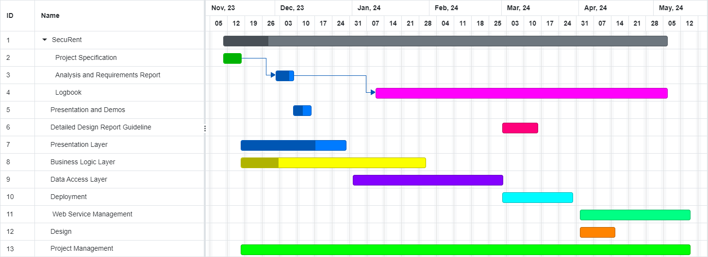

Figure 60: Gantt Chart for the Work Packages Allocated

## 4.4 Ensuring Proper Teamwork

Collaboration is the key to success in the SecuRent project. To ensure that everyone collaborates, we have set up a Jira project management page. Next, we assigned each group member a task, giving responsibility to everyone. Thus, instead of merely talking about the distribution of the tasks, we are writing them down and assigning the tasks explicitly to everyone. Hence, everyone feels involved as they are taking responsibilities (through tasks), based on their prior experiences or willingness to commit. Moreover, we decided to have leaders for the front end and the back end side, to ensure that different people share the role of leadership in different aspects. For instance, Yunus is the leader of the front end team, while Cengizhan is the leader of the back end team. In addition, Yusuf is responsible for implementing the data access layer as well as leading the design process. Arda is the SCRUM Master due to his prior experience on Agile and SCRUM in the company he works. Kaan is the product owner as he has connections in the domain and has formulated the very idea of the SecuRent application. Consequently, each team member has assigned a leadership role in a particular field. With the sharing of leadership in different aspects of the project, we aim to increase the efficiency and joy as everyone volunteered to take leadership according to their skills and interests.

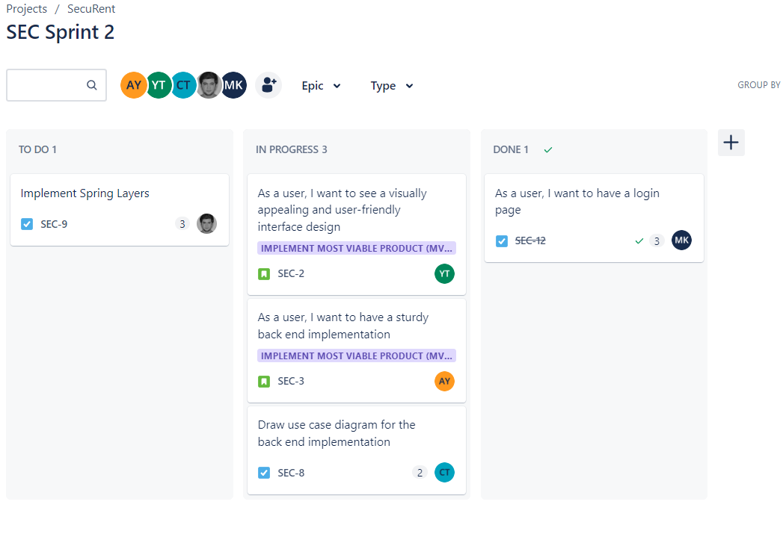

Figure 61: Sharing of tasks and stories across different team members on SCRUM board

Naturally, different teams have different directories in Github. Hence, each team leader is also responsible for checking the commits pushed to Github. Thus, issues related to different teams will be resolved under the supervision of the team leaders. Therefore, each team will be self contained in their internal tasks and will be communicating with other teams regarding the involvement of different parties. Consequently, everyone will feel a sense of responsibility and act accordingly to produce quality during the development process.

## 4.5 Ethics and Professional Responsibilities

SecuRent is an application which is intended to have a national impact on the aspect of house renting. Its purpose is to enhance the house renting process with the power of digitalization and ease the renting process for both tenants and landlords. The application does not have a specific target group. Hence, it does not make any discrimination against any individual on the grounds of nationality, ethnicity, religion, gender, and age. Anyone can use the application through the web. Moreover, we are expecting SecuRent to have a global impact on easing the renting process for both tenants and landlords. It will improve and protect the rights of the tenants worldwide, given that the application extends to the markets outside Turkey, as SecuRent empowers the usually exploited tenants against the illegitimate rent price increases brought by landlords.

SecuRent has an economic impact as well, since it will facilitate in the national level incorporating the government’s interference. As SecuRent has a feature in which tenants are paying the deposits to the government, the government will be able to make investments with the collected funds. Currently, there are nearly 6 million houses in rent in Turkey [6]. On average, the rent price is 20 thousand TL in Turkey. If we assume that all these tenants start using SecuRent, an amount of 120 billion TL would be stored in the government’s vault as deposits. Given that there is a 45% investment rate currently, almost 50 billion TL would be returned from an investment if the government were to make investments. Hence, with the adoption of SecuRent as a government supported nationwide application, both tenants and landlords will store their deposits safely under the supervision of the government, while the government will be making investments with the collected amount of money in particular time. Ultimately, deposits will be returned to either tenants or landlords, while the government will be making investments with the collected money before returning it.

SecuRent has an environmental impact as well. It reduces the amount of paper used in the renting process as the process itself is digitalized. Hence, less paperwork and faster interactions between different parties help save the resources of our nation and the world in general.

## 4.6 Planning for New Knowledge and Learning Strategies

Learning objectives appear as crucial milestones for the success of SecuRent. As a group divided into teams, we have different learning objectives for different groups. For front-end team, we have the following learning objectives:

* JavaScript
* React.js
* Bootstrap
* Node.js
* HTML
* CSS
* Jasmine
* Karma
* Axios

For back-end team, we have the following learning objectives:

* Java
* Spring Boot
* Postman
* PostgreSQL

Moreover, both teams will learn about SonarQube and how to write clean code. Moreover, all the members will learn about Amazon EC2 and hosting concepts, because of interest.

All of the members have prior information about JavaScript, HTML, CSS and Java thanks to the CS 315, CS 319, and CS 101/102 courses. However, we will delve deeper into them to produce an efficient and high-quality application. Furthermore, we are planning to take a cloud computing course (CS 443) to enhance the process of hosting and ultimately grasp the idea easier. Last but not least, we will use free YouTube videos, free documentation and Udemy courses to reach our learning objectives. Furthermore, we will do literature review and trial and error to learn and practice our knowledge, as well.

# **5.** **Glossary**

Deposit: Amount of money paid at the beginning of the renting period. In principle, tenants are paying the deposit to the landlords. Throughout the duration of the contract, the landlord keeps the deposit. When the contract expires, the landlord keeps the deposit if the house is damaged. Otherwise, the landlord returns the deposit to the tenant.

# **6.** **References**

[1] *trthaber.com.* [Online]. Available: <https://www.trthaber.com/haber/ekonomi/kiracinin-kontrat-suresi-dolmadan-kira-artisi-yapilabilir-mi-656837.html>. [Accessed: Dec. 8, 2023].

[2] *ntv.com.tr.* [Online]. Available: <https://ntv.com.tr/galeri/ntvpara/ekim-ayi-kira-artis-orani-ne-kadar-oldu-2023-ekim-ki> ra-zammi-ne-kadar-kac-tl,cOJ47hrCv0W1UJ9d43eD8A/33F1JXTgJU2_UkBzJF5AWQ. [Accessed: Dec. 8, 2023].

[3] *endeksa.com*. [Online]. Available: https://www.endeksa.com/tr/. [Accessed: Nov. 15, 2023].

[4] *mydeposits.co.uk*. [Online]. Available: https://www.mydeposits.co.uk/join-now/. [Accessed: Nov. 16, 2023].

[5] *amazon.com.* [Online]. Available: <https://docs.aws.amazon.com/AWSEC2/latest/UserGuide/concepts.html>. [Accessed: Dec. 8, 2023].

[6] *emlakjet.com.* [Online]. Available: <https://www.emlakjet.com/haber/haber/turkiyede-kac-hane-oturdugu-evde-ev-sahibi>. [Accessed: Dec. 8, 2023].